

**ADMAS UNIVERSITY**

**FACULTY OF INFORMATICS**

DEPARTMENT OF COMPUTER SCIENCE

**PROJECT TITLE: -ONLINE EDUCATIONAL CERTIFICATE VERIFICATION SYSTEM FOR ADMAS UNIVERSITY**

By

Group Member

1. Eferata Melekea …………..................................................................1900/15
2. Aschalewu Abebe.............................................................................1673/15
3. Eman Hashim...................................................................................2385/15
4. Medhin Mehari.................................................................................0348/15

**Advisor Name: -** HagosG (MSc.)

A SENIOR PROJECT SUBMITTED TO THE DEPARTMENT OF COMPUTER SCIENCE

IN CANDIDACY FOR THE Partial Fulfillment Of DEGREE OF BACHELORS OF SCIENCE

Computer Science

February, 11/2019 E.C

**Addis Ababa, Ethiopia**

**ADMAS UNIVERSITY**

**FACULTY OF COMPUTING**

DEPARTMENT OF COMPUTER SCIENCE

**PROJECT TITLE: -ONLINE EDUCATIONAL CERTIFICATE VERIFICATION SYSTEM FOR ADMAS UNIVERSITY**

By

Group Member

1. Eferata Melekea ………....................................................................1900/15
2. Aschalewu Abebe.............................................................................1673/15
3. Eman Hashim...................................................................................2385/15
4. Medhin Mehari.................................................................................0348/15

**Advisor Name: -** HagosG (MSc.)

A SENIOR PROJECT SUBMITTED TO THE DEPARTMENT OF COMPUTER SCIENCE

IN CANDIDACY FOR THE Partial Fulfillment Of DEGREE OF BACHELORS OF SCIENCE

Computer Science

February, 11/2019 E.C

**Addis Ababa, Ethiopia**

# DECLARATION

This is due to declare that this project which is done under the supervision of Mr. Hagos and having the title Online Educational Certificate Verification system is the only contribution of group member is

1. Efrata Melekea
2. Aschalew Abebe
3. Eman Hashim
4. Medihin Mehari

No part of the project work has been reproduced illegally which can be considered as plagiarism. All referenced parts have been used to argue the idea and have been cited properly. We will be responsible for any consequence if violation of this declaration is proven.

Date:---------------------

Group Member

**Full name.....................................................................................................** Signature

1. Eferata Melekea …………..................................................................
2. Aschalewu Abebe................................................................................
3. Eman Hashim......................................................................................
4. Medhin Mehari.....................................................................................

**Approval Form**

This is to confirm that the project report allowed online educational certificate verification system submitted to Admas University, College of Computing and Informatics Department of Computer science by Efrata Melkea, Aschalew Abebe,Eman Hashim, Medihn Mehari approved for submission.

------------------------------------------------- ------------------------------ ---------------------- Advisor Name Signature Date

------------------------------------------------- ------------------------------ ---------------------- Department Head Name Signature Date

------------------------------------------------- ------------------------------ ---------------------- Examiner 1 Name Signature Date

------------------------------------------------- ------------------------------ ---------------------- Examiner 2 Name Signature Date

------------------------------------------------- ------------------------------ ---------------------- Examiner 3 Name Signature Date

**Acknowledgement**

First of all our great gratitude goes our GOD. Next to this we would like thank everyone who is on the side of us until the completion of this project. Especially we would like to acknowledge our Advisors Mr. Hagos G/medhin who has supported us from the start in making this project by giving His valuable comments and corrections. And also we would like to thank the registrar of Mr.Markos for showing all the information and materials we needed in making the project. Finally we appreciate the help and support from all persons who were directly or indirectly involved in our project.

**Table of Contents**

Declaration III

Approval Form IV

Acknowledgment V

List of Figure X

List of Table XI

List of Abbreviation XII

Abstract XIII

**CHAPTER ONE 1**

1. Introduction 1

1.1. Background of the organization 1

1.2. Statement of the problem 2

1.3. Objective of the project 2

1.3.1. General objective 2

1.3.2. Specific objective 3

1.4. Feasibility Analysis 3

1.4.1. Technical Feasibility 3

1.4.2. Operational Feasibility 3

1.4.3. Economical Feasibility 3

1.5. Scope and Limitation of the project 2

1.5.1. Scope of project 4

1.5.2. Limitation of the project 4

1.6. Significance of the project 4

1.6.1. Beneficiary of the project 5

1.7. Methodology of the project 6

1.7.1. Data collection tools/techniques 6

1.7.2. System Analysis and Design 6

1.7.3. System Development Model 7

1.7.4. Testing Methodology 7

1.7.5. Development tools and technologies 7

1.7.5.1. Fronted Technologies 7

1.7.5.2. Backend Technologies 7

1.7.5.3. Documentation and Modeling Tools 7

1.7.5.4. Deployment Enviroment 7

1.8. Budget and time schedule of the project 8

1.8.1. Budget of the project 8

1.8.2. Time Schedule of the project 9

1.9. Team Compostion 10

1.10. Document Organization 10

**CHAPTER TWO 11**

2. DESCRIPTION OF THE EXISTING SYSTEM ................................................................ 11

2.1. Introduction of Existing System..................................................................................... 11

2.2. Users of Existing System ............................................................................................... 11

2.3. Major Functions of the Existing System ........................................................................ 12

2.4. Forms and Other Documents of the Existing Systems (if any) ...................................... 13

2.5. Drawbacks of the Existing System ................................................................................ 15

2.6. Business Rules of the Existing System .......................................................................... 15

**CHAPTER THREE ................................................................................................................. 16**

3. PROPOSED SYSTEM ...................................................................................................... 16

3.1. Functional Requirements................................................................................................ 16

3.2. Nonfunctional Requirements.......................................................................................... 16

3.2.1. User Interface and Human Factors ......................................................................... 16

3.2.2. Hardware Consideration ......................................................................................... 17

3.2.3. Security Issues ........................................................................................................ 17

3.2.4. Performance Consideration..................................................................................... 17

3.2.5. Error Handling and Validation................................................................................ 17

3.2.6. Quality Issues .......................................................................................................... 17

3.2.7. Backup and Recovery ............................................................................................. 18

3.2.8. Physical Environment ............................................................................................. 18

3.2.9. Resource Issues ....................................................................................................... 18

**CHAPTER FOUR.................................................................................................................... 19**

4. SYSTEM ANALYSIS ....................................................................................................... 19

4.1. System Model................................................................................................................. 19

4.1.1. Use Case Model ...................................................................................................... 19

4.1.1.1. Use Case Diagram ........................................................................................... 21

4.1.1.2. Use Case Description....................................................................................... 22

4.1.1.3. Use case Scenario ............................................................................................ 31

4.2. Object Model.................................................................................................................. 32

4.2.1. Class Diagram ......................................................................................................... 32

4.2.2. Data Dictionary ....................................................................................................... 33

4.3. Dynamic Model .............................................................................................................. 35

4.3.1. Sequence Diagram .................................................................................................. 35

4.3.2. Activity Diagram .................................................................................................... 36

4.3.3. State Chart Diagram................................................................................................ 37

**CHAPTER FIVE 38**

5. SYSTEM DESIGN ............................................................................................................ 38

5.1. Design Goals .................................................................................................................. 38

5.1.1. Performance ............................................................................................................ 38

5.1.2. Dependability ..........................................................................................................38

5.1.3. Maintenance ............................................................................................................ 38

5.1.4. End user .................................................................................................................. 38

5.1.5. Priorities of Design Goal ........................................................................................ 38

5.2. Current System Architecture (if any) ............................................................................. 39

5.3. Proposed System Architecture ....................................................................................... 39

5.3.1. Subsystem Decomposition and Description ........................................................... 40

5.3.2. Hardware/Software Mapping .................................................................................. 42

5.3.3. Detailed Class Diagram ..........................................................................................43

5.3.4. Persistent Data Management................................................................................... 44

5.3.5. Access Control and Security ................................................................................... 45

5.4. Packages ......................................................................................................................... 46

5.5. Algorithm Design ........................................................................................................... 46

5.6. User Interface Design ..................................................................................................... 47

**LIST FIGURE**

Figure 1.Student Tempo Certificate Format 13

Figure 2.Student Registration Form Format 14

Figure 3.UML Use Case Diagram 21

Figure 4.UML Class Diagram 32

Figure 5.Sequence Diagram 35

Figure 6.Activity Diagram 36

Figure 7.User Login State Chart Diagram 37

Figure 8.Registration Form State Chart Diagram 37

Figure 9.Subsystem decomposition diagram 40

Figure 10.Hardware/software Mapping diagram 42

Figure 11.UML Detail Class Diagram 43

Figure 12. Sample Class Diagram 44

Figure 13.Backtracking algorithm 46

Figure 14.User Interface of Our System 47

# LIST TABLE

Table 1.Budget of the project 8

Table 2.Time Schedule of the project 9

Table 3.Team Composition 10

Table 4.Use Case Models 19

Table 5.Login Use Case Description 22

Table 6.Register Student Certificate Use Case Description 23

Table 7.Update Student Certificate Use Case Description 24

Table 8.Delete Student Certificate Use Case Description 25

Table 9.Search Student Certificate Use Case Description 26

Table 10.Create Account Use Case Description 27

Table 11.Manage Use Case Description 28

Table 12.View Request Use Case Description 29

Table 13.Request Use Case Description 30

Table 14.Employee Table 33

Table 16.Account Table 33

Table 17.Student Table 34

Table 18.Certificate Table 34

Table 19.Request Table 34

Table 20.Access Control and Security 50

## LIST OF ABBREVIATIONS

**ADMIN:-**Administrator

**AU**: Admas University

**AUOECVS: -**Admas University Online Educational verification system

**BCA:** Basic Course of Action

**BR:** Business Rule

**DB: -**Database

**DVD:** Digital Versatile Disk

**E.C: -** Ethiopian Calendar

**E.mail: -** Electronic Mail

**G.C: -** Ethiopian Calendar

**GPA:** Grade Point Average

**GUI: -** Graphical User Interface

**HTTP:-** Hyper Text Transfer Protocols

**IDE: -**Integrated Development Environment

**MS: -** Microsoft

**OECVS: -**Online Educational verification system

**OS: -** Operating System

**SQL: -** Structured Query Language

**UC: -** Use Case

**UML:-**Unifide Model Language

**ABSTRACT**

Admas University Registrar Online Educational Certificate Verification System now uses manual system. Our team initiated to implement Online Educational Certificate Verification System that enable student to manipulate students Certificate information in simpler and comfortable manner by minimizing burden of registrar officer and avoid boring manual Certificate verification system .The system enables the organization to process student information in faster, reliable, secure, and flexible manner. For security purpose the system have two classes of users, namely the administrative level and user level. The administrator, which if the manager of the registrar office has higher class of privilege for controlling the system, and users which includes students certificate information and record officer have limited access in the system according to their own privilege. Our System End users access the database through the internet and can perform certain transactions according to their authorization. The system implementation and structured and reliable information, quick and remote access, and prompt updating capabilities.

The system uses HTML,CSS,JS, PHP server side script and SQL Server 2008R2 as a backend.

# CHAPTER ONE

# INTRODUCTION

In many governmental and non-governmental institutions, including **Admas University**, after graduation, students must ensure that their academic credentials are accurate from which academic institution. This is what we call Online Educational Verification System. After the graduation, the registrar must receive the permit from the registrar, for example, to find a job and prove the evidence. The process of Verification involves the Student’s from which Institution, from which department, which Faculty, Student Full Information and others.

To check Educational Certificate must undergo through many manual process. to check educational certificate from registrar. Sometimes some officials from these departments will not present in office and students have to wait until they get the officials. This is time consuming and boring, especially when students need it urgently.

In our project we want to avoid this time consuming and boring manual system. In order to overcome this problem, we have planned to design web based online Educational Verification system for every Student.

In today’s computerized world, web based computerized system plays a great role in facilitating works and avoid unnecessary time delaines of services. It enables to access information from anywhere and avoids costs of transportation and others to access information physically like manual system. Web based systems are applied in different industries like hospitals hotels, schools and others. Online Educational Verification System is one part of this system and we are going to develop and apply this system in Admas University.

# BACKGROUND OF THE ORGANIZATION

**Admas University**, which is one of the pioneer Private Higher Education Institutions in Ethiopia,   commenced its operation in October 1998 under the name “Admas Business Training Centre.” The Training Centre then started delivering training services in certain tailor-made short-term programs. By undertaking deep assessments of further training needs and making preparations in terms of the required human and material resources, the centre upgraded itself to a college status as of April 1999, and to the status of a University College as of March 2007. Finally, after ensuring that all the requirements of Higher Education Proclamation No. 650/2009 have been met, the Ministry of Education of F.D.R.E. granted full University status to Admas as of July 2014.At present time

**Admas University** provides Certificate for students. However, the students will be returned to the school for educational Certificate Verify. because of to check that certificate in manually System.

# STATEMENT OF THE PROBLEM

Since Students have the right to proof for the evidence from the University and College. students after getting Certificate. If it is the certificate is valid or invalid. Then Come again to the university. But in this case they have to pass through much manual process. They have to visit registrar of the University and to be verify Educational Certificate.

Generally our goal is to check automat online student's educational certificate verification system. On the other hand its scope is limited to providing only valid and invalid certificate information about students. The system will do only based on final collected and submitted information by the respective department to system.

**Problems in the existing system**

* Student have to come to the registrar office for checking certificate
* Checking certificate process takes more days
* Searching information is difficult
* It does not make the students trustworthy because they have a lot of false academic credentials

## OBJECTIVE OF THE PROJECT

## General objective

The overall purpose of this project will develop web based educational certificate verfication system for Admas university

## Specific Objective

Our specific objectives will be: -

* Study Background of Organization
* identifying problem of the current system
* analyze of the existing system
* To Evaluate the alternative solutions
* To define system requirements.
* Prepare documentation
* design different web page based on privilege
* System analysis and Object design
* Implement and test the system until the organization needs is fulfill.

## FEASIBILITY ANALYSIS

## The project is feasible in terms of operational, economical and also technically.

## Technical Feasibility

Determines the level of technology available in the software development we can simply observe that the project is feasible in terms of volume of data and frequency of updating. Also we are going to use the latest software’s tools which are common in developing software nowadays because technology evolves quickly. In general we can say our software is feasible because it can be achieved within the given constraint.

## Operational Feasibility

It is a measure of how well a proposed system solves the problems. Our software will be used effectively. It is also possible to maintain and support after it has been developed and the system will result in workforce reduction which means it has high operational feasibility so the usability increases. Workers initiation for their job will be maximized

## Economical Feasibility

The system minimizes labor force. It also reduces the cost of paper for printing hard back up.

**1.5. SCOPE ANDLIMITATION OFTHE PROJECT**

## Scope of project

The scope of the project is about tasks that will be performed throughout the system. Our main goal in doing this system is making the existing manual into web based system, more efficient, less time consuming and overall a better working system and students and other customer can access the information by using web based system.

Our project aims to develop a web based Educational Certificate Verification System to help the functionalities of Admas University.

## Limitation of the Project

**The limitation of our system is: -**

* The system does not verify student grade report and student payment system for each service.

## SIGNIFICANCE OF THE PROJECT

This project has great significant for the office in terms of creating good working environment, cost minimizing, time consuming, and user satisfaction.

* The system increases performance and management
* Achieves an increase in the satisfaction of users from the new system.
* Giving access for the user and also set privilege accordingly for different users.
* Generates reliable and clear educational Certificate report.
  + 1. **Beneficiary of the project**

The project improves the quality of internal operations and ever faster than current system

**Admas University:** The University will have good image because student’s Certificate information is kept in safe manner.

**Registrar Office:** For main registrar the system helps to manage the data in safer manner without losing any students data.

* Improve accuracy in handling or managing data
* Minimize time delay
* Fast decision making
* Reliability.

**Manager of Registrar:** Can manage everything in simpler manner and reduces work load.

**Record officer:** Can record student’s certificate data fast; reduce work load and over tension with the work.

**Students**: Students can get and verify Own Certificate information securely and easily.

**Working Team:**

* Gets experience of working in real world environment
* Improve skill and knowledge.

**Departments and the Faculty:** Reduces work load for approving and reviewing students Certificate manually.

## METHODOLOGY OF THE PROJECT

The methods that facilitate us to capture information about requested system is called Methodology. We will gather information and data through different mechanisms.

While in doing our project, we will use the following methods of data collection or fact finding techniques to gather information regarding the problems of the existing and requirements of the proposed system.

## Data Collection Tools/Techniques

**Document analysis:** We will analyse documents like the certificate verification form which helps to build the contents of the registration form.

## System Analysis and Design

For this study the team members object oriented system analysis and design by unified modeling language (UML) because in order to modify the analysis and design phase if necessary when team member are implementation phase and increase reusability. The goal of this section is to provide the basic overviews of the system that team member are going to develop. In UML (Unified modeling language) include three diagrams this are: Use Case Diagram (UCD), Entity Relationship Diagram (ERD) and Activity Diagram (AD).

* **Use case diagram:** Use case diagrams are used to indicate graphically the interactions between the system and external system and users.
* **Entity Relationship Diagram**: is a graphical representation of entities and their relationships to each other.
* **Activity diagram:** is also a diagram that indicates how the systems are doing the work flows. Activity Diagrams are used to Document the logic of a single operation /methods, a single use case, or the flow of logic of a business operation. This diagram uses the symbol for the followings.

## System Development Model

We do have five way of software development life cycle models ,these are Waterfall model, iterative, spiral, V-model or Big Bang Model.

We have selected Waterfall model because of the following reasons

* Simply and easily to understand and use.
* Easy to arrange tasks.
* Clear define stages.
* Phases are processed and completed one at a time

## Testing Methodology

There are different types of testing methodology. In our project we do have selected unit testing methodology because of the following reasons unit tests are very low level, close to the source of our application. They testing individual methods and functions of the classes, components or modules used by own software. Unit tests are in general quite cheap to automate and can be run very quickly by a continuous integration server.

## Development Tools and Technologies

For our proposed system we need the following Hardware and Software specifications.

* + - 1. **Frontend Technologies**
* Notepad++,HTML 5,CSS,JavaScript,bootstrap,Adobe Photo Shop cs4.
  + - 1. **Backend Technologies**
* Notepad++, PHP 5,MYSQL 5
  + - 1. **Document and Modeling Tools**
* Edraw Max,Visio ,Ms-Word,Ms_Excel,Ms_Powerpoint,Nitro PDF.
  + - 1. **Deployment Environment**
* **xampp**-win32-5.6.38 , Mozilla Firefox 54.0b7.

# Budget and Time Schedule of the Project

# Budget of the Project

It is important to identify cost and benefit factors, which can be categorized as development costs and operating costs. This is an analysis of the costs to be incurred in the system and the benefits derivable out of the system. Total of all costs incurred from initiation to implementation of a project.

|  |  |  |
| --- | --- | --- |
| **Development Cost** |  |  |
| **Names** | **Quantity** | **Amount** |
| Paper | 2 packet | 200.00 birr |
| Flash disk | 2 | 300.00 birr |
| For printing purpose | - | 300.00 birr |
| Publishing cost | - | 300.00 birr |
| Internet cost | - | 240.00 birr |
| Pen | 20 | 100.00 birr |
| DVD-RW (4.7 gab) | 2 | 60 |
| Transports | - | 500 birr |
| Computer | 1 | 6,000 birr |
| Total | - | 8000 birr |

Table 1 Budget of project

* + 1. **Time Schedule of the Project**

The schedule is a significant part of the project. It defines what you intend to do and when you plan to do it. You should consider how long each activity will take, which activities must precede others, and how much overlap is possible or desirable. The schedule identifies tasks to be performed, milestones to be met, and the estimated number of hours for each task.

|  |  |  |  |  |  |  |  |  |
| --- | --- | --- | --- | --- | --- | --- | --- | --- |
| Month | November | December | January | February | March | April | May | June |
| Introduction |  |  |  |  |  |  |  |  |
| DESCRIPTION OF THE  EXISTING SYSTEM |  |  |  |  |  |  |  |  |
| PROPOSED SYSTEM |  |  |  |  |  |  |  |  |
| SYSTEM ANALYSIS |  |  |  |  |  |  |  |  |
| SYSTEM DESIGN |  |  |  |  |  |  |  |  |
| IMPLEMENTATION AND  TESTING |  |  |  |  |  |  |  |  |
| CONCLUSION AND  RECOMMENDATION THEN  PRESENTATION |  |  |  |  |  |  |  |  |

The time arranged for the smooth flow of the project by the team members is as in the table

Table 2 Plane time schedule of project

* 1. **Team Composition**

|  |  |  |  |
| --- | --- | --- | --- |
| **Stud.no** | **Name** | **Id no** | **Responsibility** |
| 1 | Eferata Melekea | 1900/15 | **All activities** |
| 2 | Aschalew Abebe | 1673/15 | **All activities** |
| 3 | Eman Hashim | 2385/15 | **All activities** |
| 4 | Medhin Mehari | 0348/15 | **All activities** |

Table 3 team composition

# Primary contact person include

Name: - Efrata Melkea

Address: - Addis Abeba

Phone number: - 0912367784

E-mail:- [Efrata4143@gmail.com](mailto:Efrata4143@gmail.com)

* 1. **Document Organization**

In general we want to describe about for the whole chapter of our project documentation about introduction part of our project, background study, statement of problem, objective and feasibility study, our project scope and limitation, significance of the project and by what way method data gather for our project and identify what type of technology needs for developing our system, and how much expense the cost of the project and when we finished our Project system with their Schedule and finally list out who are the project team composition, and other describe introduction to existing system with their draw back and the existing system business rule. And list our system functional and Non Functional requirement, Finally we want to put system analysis part of project with their model like **System Model, Object Model**, and **Dynamic Model** and describe our project system design part. In **system design** part is the process of defining the architecture, modules, interfaces, and data for a **system** to satisfy specified requirements. We assume that we describe the project main points in this document efficiently and effectively.

**CHAPTER TWO**

**2. DESCRIPTION OF THE EXISTING SYSTEM**

**2.1. Introduction of Existing System**

The online educational verification system project is a Greenfield engineering project. There is no current system to replace and the task of OECVS is not accomplished by now. But temporarily the Admas University works in a traditional way that it’s impossible to say a manual system (lack of necessary document) to check Student Certificate that is an organized to work and more time consuming. Including the present of Admas University and other leaders or student connect to each other by phone , letter ,report and every time concerning their works is paper based that to cost for writing materials .

**2.2. Users of Existing System**

Currently the Admas University works in a traditional way that it’s impossible to say a manual system user

**The Following users are for Existing System**

* **Dean of student**
* He/she is responsible for control the overall activities.
* He/she is a person who administer for each Student Information.
* **Student Record Officer**
* He/she is a person who manages information of for each student.
* If somebody ask some information then Provides information.
* He/she generate report and sends to the registrar manager.
* **Student/Customer**
* They are users who accesses service from Admass University Educational Verification system.
* After Graduation every student check and verify own Educational certificate using this system.
* **Registrar**
* Registrar is used to give the full information of students (Name, Id, GPA, Graduate, Under Graduate, phone, Email, etc) to Dean of student.
* He/she is a person who manages for each Student Information in Admas University.
* After Graduation To Give Certificate for Each Student.

**2.3. Major Functions of the Existing System**

Even if the existing system is manual system as it has major function it also has some strong side that we need to be preserved are:

* Provide the required infrastructure to the students.
* Protecting Student Educational Certificate using physical security.
* Register Educational Certificate information in registrar office.
* Temporarily Student Certificate Information Register in Excel.
* Each student certificate check and verify by manually way.

**2.4. Forms and Other Documents of the Existing Systems (if any)**

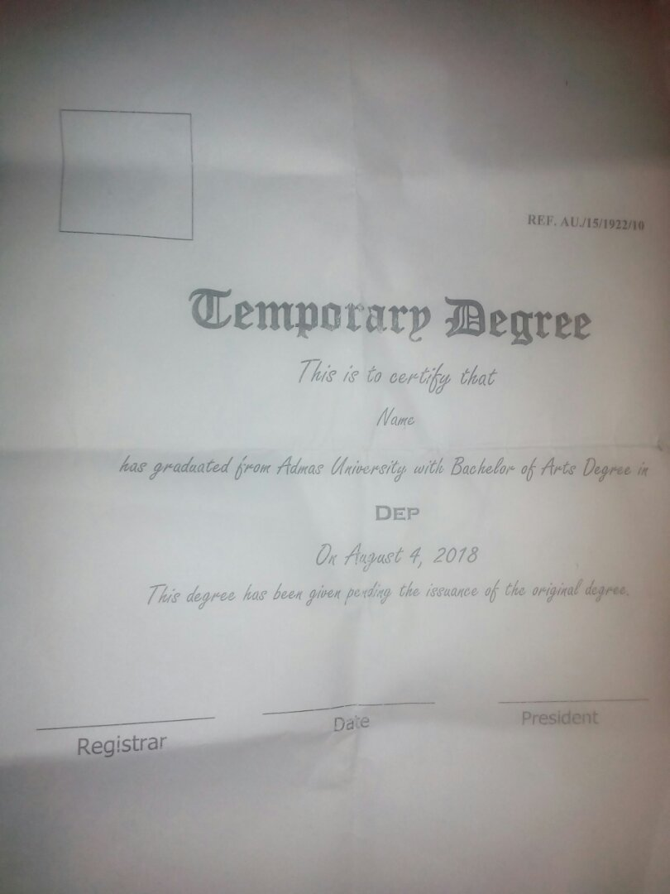

Figure 1 Student Tempo Certificate Format

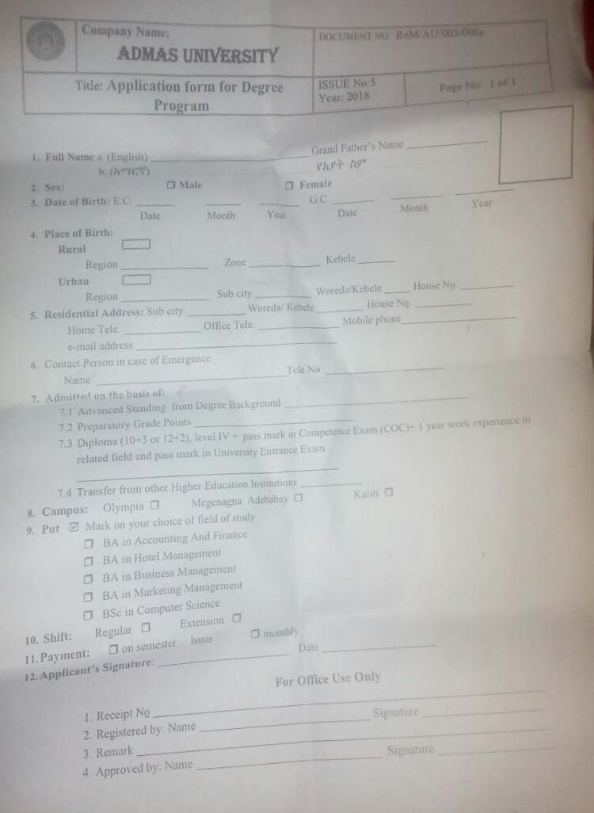

Figure 2 Student Registration Form Format

**2.5. Drawbacks of the Existing System**

The existing system had many problems. For example, if the student wants to check certificate from the university by tradition way so the process of proof evidence is boring and time consuming.

* Student should must come to the registrar office for checking certificate
* Checking certificate process takes more days
* Searching information is difficult
* Student Certificate Paper is easily damaged and can be damaged
* It does not make the students trustworthy because they have a lot of false academic credentials

**2.6. Business Rules of the Existing System**

At this moment the Online Educational Certificate Verification System uses the new promotion policy of the Certificate.

* The student must be register.
* The Student Must be Attend the Whole course to get Certificate.
* The student must be Class Complete all expected course.
* Students after Gradations check Clearance after that get certificate.
* Student get certificate by Department with educational level then after that Check and Verify by Certificate Number.
* Students should not change their Educational certificate without the permission of the registrar with sufficient reason.
* Educational Certificate should be arranged and registered before the checking and verify.
* The student must keep the Educational Certificate Number properly.
* Two or more students never sleep in one bed.
* One student should not check others Educational Certificate.
* Student has to check Educational certificate everywhere and every time online.

**CHAPTER THREE**

**3. PROPOSED SYSTEM**

After observing the current manual system and identifying all the problems occurred during every activity on the existing system, the project team has decided to design an automated online Educational Verification System Admas University **OECVS** for office and system that can be easily access and work at any time and place.

The proposed system will use the major functionality of existing system and able to advance with speed and response of the system.

**3.1. Functional Requirements**

The functional requirements that the OECVS will provide:

* Create and manage User account.
* Register, update, delete and Search students Certificate.
* Check and verify for each student educational certificate by using Search engine.
* It has User login.
* Send and View Request
* Search User Account.

**3.2. Non-Functional Requirements**

The system will have the following features.

**3.2.1. User Interface and Human Factors**

* Simple to design: the user interface easy to understand and user friendly interface.
* The text is very clear and readable.
* Easy to use the system. This is achieved by including buttons and objects to simplify the use of the system.

**3.2.2. Hardware Consideration**

Our system has any type of hardware and software compatibility with another additional computer hardware device like Printer, Scanner and every Smart Phone platform. Our system interacts with other hardware system, because our system runs anytime and anywhere over internet.

**3.2.3. Security Issues**

The data can be stored in highly secure manner and immune from any hacking attempts. So our system is protected against internal and external intrusions or against an authorized user by using security level and in additional user password **md5** encryption security algorithm applied our system.

**3.2.4. Performance Consideration**

* Our system response time to searching Educational Certificate verification process gives for customer in less than 100 microseconds.
* The system should quickly display full certificate information as soon as the students enter their certificate number and id number.
* The system has quickly will report. How many students taken Educational certificate.
* High performance because our system designed will use low utilization of system resource in terms of space and time.

**3.2.5. Error Handling and Validation**

When the users of the system interact with the system errors may appear. To control these inaccuracies the system will generate different messages.

**When user makes some error:-**

* The system should display error message if the user input invalid character
* The system must have capacity for error handling.
* The system should check and verify for each textbox and other like what type of data input in the system.
* The System has Error Handling Mechanism. Just like sometimes error happen like the user input invalid username and password then show for user that error.

**3.2.6. Quality Issues**

* the system should be tolerable of fault in case of SW and HW failure.
* The system should available for further use while needed.
* The users have to get services from the system rapidly.

**3.2.7. Backup and Recovery**

Our system has automatically every day backup using backup and recovery mechanism. Because the risk of data lost might happen do a lot of reasons such as: computer virus, computer hacker, sudden accident on data storages/data center, data theft or power fluctuation. You can also using external storage media like flash disk, External hard disk, CD, DVD and offline backup. We will recover it from external storage device and offline backup.

**3.2.8. Physical Environment**

Our system is deployed on **web server** computer within organization of Datacenter. In additional our system needed the following service. Because of there so many external factors such as protect from weather conditions like fire, water flood etc

* Required Server Computer
* Air conditioning is required.
* Our data center ups are required.
* Datacenter must have a cool place.
* Datacenter is put in physical and logical secure area.

**3.2.9. Resource Issues**

Extra time and cost minimized our system and student data redundancy controls because of in manually system so extra cost of paper and transportation cost to come back registrar office.

**CHAPTER FOUR**

**4. SYSTEM ANALYSIS**

**System Analysis:-**it is a process of collecting and interpreting fact, identifying the problems, and decomposition of a system into its components. And what the system should do.

**4.1. System Model**

System modeling is used to describe the system under development by showing its functionality using use cases, static behavior using class diagram and dynamic behavior using sequence and activity diagram.

* + 1. **Use Case Model**

Use cases provide to capture system requirements, and communicate with the end users. A use case is best to identify the actors and defining how the actors will be able to interact with the system.so we have to identify each actor with use case for our system So our system has 3 Actors ,9 Use Case.

|  |  |
| --- | --- |
| **Actor** | **Use case** |
| 1. Administrator 2. Record officers 3. Students | 1. Login 2. Register Student Certificate 3. Update Student Certificate 4. Delete Student Certificate 5. Search Student Certificate 6. Create Account 7. Manage User 8. View Request 9. Request Send |

Table 4 Use Case Model

* Actors Description

We identify the following factors:-

* **Administrator: -** The system administrator controls all over activities of the system. He/she creates account for users, removes users account, and reset users account and approves student educational certificate’s
* **Record Officer:** Record officer records student certificate information, generates certificate report and student information details. Each record officer has their own user account.
* **Student:** Students c can verify and check certificate online after submitted by the registrar.

**4.1.1.1. Use Case Diagram**

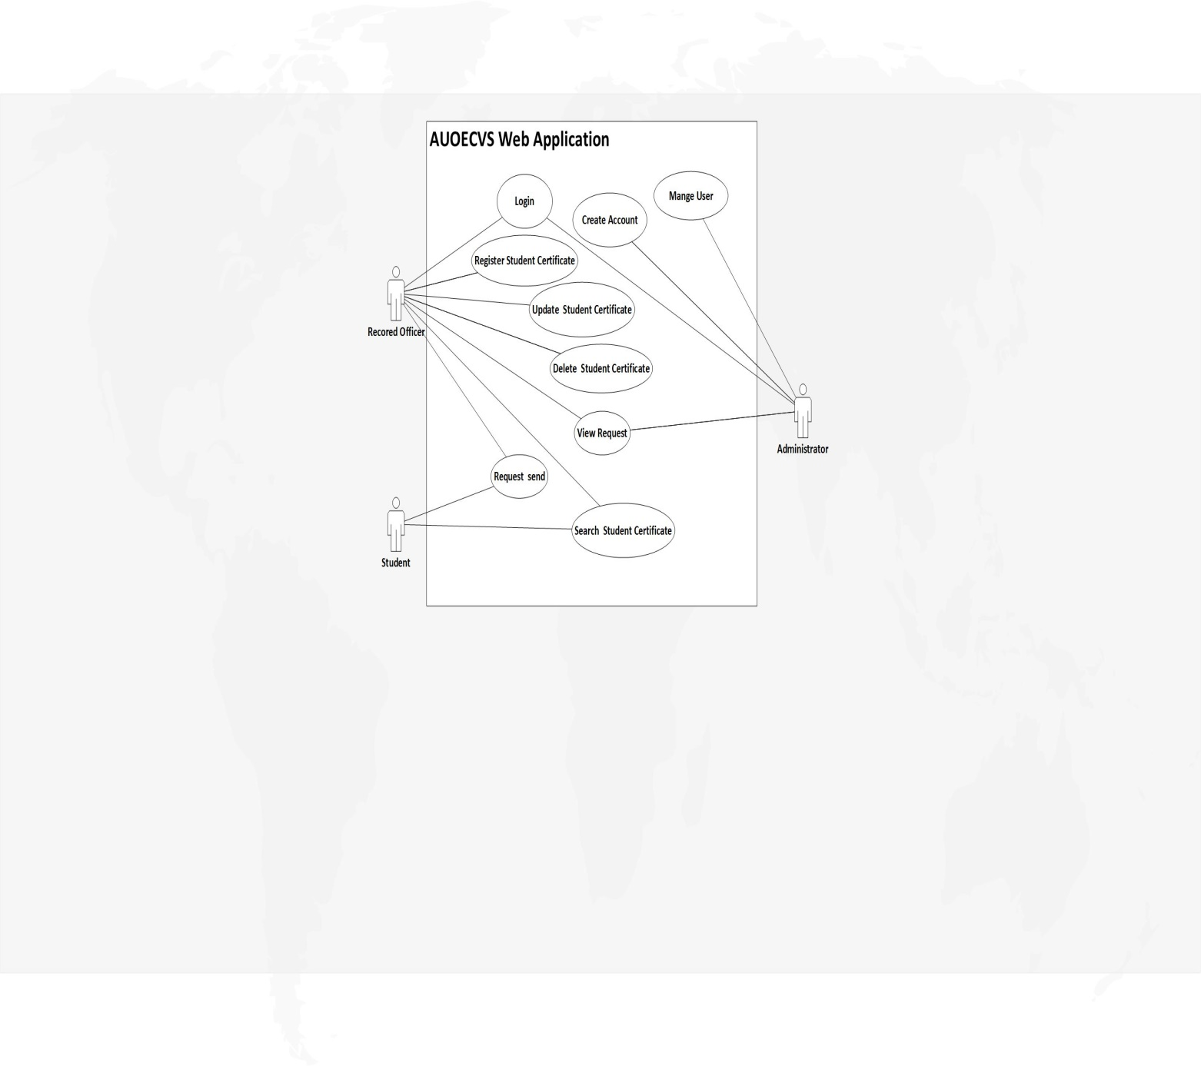

Figure 3: Overview of Online Educational Verification System use cases (UML use case diagram).

**4.1.1.2. Use Case Description**

1. Login

|  |  |
| --- | --- |
| **Use Case Name** | **Login** |
| **Use Case ID** | **UC1** |
| **Description** | User who have privilege to access the system’s functionalities should be able to login each time he/she wants to use the  System |
| **Actor** | Administrator and Record Officer |
| **Pre-condition** | The user must be registered to user account. |
| **Post Condition** | If the user is authenticated the user logged into the system and the system displays all features available for the role associated  to the user. |
| **Basic Course Of Action (BCA)** | |
| This use case starts when the user accesses the login feature of the system by selecting his privilege.   1. The user browses the web application. 2. The system displays a login form 3. User selects his privilege 4. The user enters his/her username and password [**A1]** 5. The user clicks login button 6. The system validates the entered information. 7. The system takes the user to his/her interface. 8. The use case ends. | |
| **Alternative course of action** | |
| 4. User fills invalid username and/or password | 1. The system displays error message. 2. The system prompts the user to reenter the valid information. 3. Use case continues with **BCA 4**. |

Table 5 Login Use Case Description

1. Register Student Certificate

|  |  |  |
| --- | --- | --- |
| **Use Case Name** | **Register Student Certificate** | |
| **Use Case ID** | **UC2** | |
| **Description** | This use case is to register senior student educational certificate, new student certificate, and record full student information to the system. | |
| **Actor** | record officer | |
| **Pre-condition** | The user wants to register new record i.e. when starts the class that student, check student complete the whole expected course. | |
| **Post Condition** | Record stored in database if the information filled is valid | |
| Includes | Login | |
| **Basic Course Of Action (BCA)** | | |
| This use case starts after user the logins to the system   1. User login into the system 2. The user clicks the Register menu 3. System displays record form. 4. User fills accurate data**[A1]** | | 1. User clicks register button 2. The system validates the entered information. 3. The system saves data into the database. 4. The use case ends. |
| **Alternative course of action** | | |
| 4.User fills invalid data | 1. The system displays error message. 2. The system prompts the user to reenter the valid information. 3. Use case continues with **BCA 4.** | |

Table 6 Register Use Case Description

1. Update Student Certificate

|  |  |  |
| --- | --- | --- |
| **Use Case Name** | **Update Student Certificate** | |
| **Use Case ID** | **UC3** | |
| **Description** | This use case is to update student Educational Certificate information. | |
| **Actor** | record officer | |
| **Pre-condition** | User login and information must first exist in the system database and the user wants to update the information | |
| **Post Condition** | Wrong data is corrected | |
| **Includes** | Login, Search. | |
| **Basic Course Of Action (BCA)** | | |
| This use case starts after the user logins to the system   1. User login into the system 2. The user clicks update menu 3. System displays update form 4. User fills accurate data**[A1]** | | 1. User clicks update button 2. The system validates the entered information. 3. The system saves data into the database. 4. The use case ends. |
| **Alternative course of action** | | |
| 4. User fills invalid data | 1. The system displays error message. 2. The system prompts the user to reenter the valid information. 3. Use case continues with **BCA 4**. | |

Table 7 Update Certificate Use Case Description

1. Delete Student Certificate

|  |  |  |
| --- | --- | --- |
| **Use Case Name** | | **Delete Student Certificate** |
| **Identifier** | | **UC4** |
| **Description** | | This use case is to delete student Certificate information from the database. |
| **Actors** | | record officer |
| **Precondition** | | The user is logged in to the system and The item must exist  First. |
| **Post Condition** | | The record is removed from the database (list). |
| **Includes** | | Login |
| **Basic course of action** | | |
| This use case starts after the user logins to the system   1. User login into the system 2. User clicks on delete record menu 3. System displays delete record form 4. User enters the key he/she want to delete 5. The user clicks delete button 6. The system verifies whether the information is available or not. **[A1].** 7. The system deletes/removes record. 8. End use case. | | |
| **Alternative course of action** | | |
| 6. In case the information is not available | 1. The system determines the information is not available in the system. 2. The system informs the user the information is not found via result screen and no data is deleted. 3. End use case. | |

Table 8 Delete Certificate Use Case Description

1. Search Student Certificate

|  |  |  |
| --- | --- | --- |
| **Use Case Name** | | **Search Student Certificate** |
| **Identifier** | | **UC5** |
| **Description** | | Display available information in the system i.e. student certificate information using search key. |
| **Actors** | | All Actor |
| **Precondition** | | The user is logged in to the system or not logged |
| **Post Condition** | | The user gets information. |
| **Includes** | | Login |
| **Basic course of action** | | |
| This use case starts after the user logins to the system   1. User login into the system 2. The users click on search menu 3. The user select search certificate list accordingly 4. The system displays a search form 5. The user enter the search key to be searched 6. The system verifies whether the information is available or not. **[A1].** 7. The system display result screen which indicate the available information. 8. End use case. | | |
| **Alternative course of action** | | |
| 6. In case the information is not available | 1. The system determines the information is not available in the system. 2. The system informs to user the information is not found via result screen. 3. Use case continues with **BCA 6**. | |

Table 9 Search Certificate Use Case Description

1. Create Account

|  |  |
| --- | --- |
| **Use Case Name** | **Create account** |
| **Use Case ID** | **UC6** |
| **Description** | This use case is to create account for valid users |
| **Actor** | Administrator |
| **Pre-condition** | Administrator login and new valid user wants to use the system |
| **Post Condition** | New account is created and new user starts to use the system |
| **Includes** | Login |
| **Basic Course Of Action (BCA)** | |
| This use case starts after the user logins to the system   1. Administrator login into the system 2. Administrator clicks create account menu 3. System displays create account form. 4. Administrator fills accurate data**[A1]** 5. Administrator clicks create new account button 6. The system validates the entered information. 7. The system saves data into the database. 8. The use case ends. | |
| **Alternative course of action** | |
| 4. Administrator fills invalid data | 1. The system displays error message. 2. The system prompts the user to reenter the valid information. 3. Use case continues with **BCA 4.** |

Table 10 Create Account Use Case Description

1. Manage User

|  |  |  |
| --- | --- | --- |
| **Use Case Name** | | **Manage User** |
| **Identifier** | | **UC7** |
| **Description** | | This use case is to User Account from the database. |
| **Actors** | | Administrator |
| **Precondition** | | The user is logged in to the system and The item must exist  first. |
| **Post Condition** | | The User is Update, Delete, Enable and disable from the database (list). |
| **Includes** | | Login |
| **Basic course of action** | | |
| This use case starts after the user logins to the system   1. User login into the system 2. User clicks on Manage User menu 3. System displays Update account form 4. User enters the key he/she want to Update 5. The user clicks Update button 6. The system verifies whether the information is available or not. **[A1].** 7. The system Update or Delete User. 8. End use case. | | |
| **Alternative course of action** | | |
| 6. In case the information is not available | 1. 1. The system determines the information is not available in the system. 2. The system informs the user the information is not found via result screen and no data is deleted. 3. End use case. | |

Table 11 Manage User Use Case Description

1. View Request

|  |  |  |
| --- | --- | --- |
| **Use Case Name** | | **View Request** |
| **Identifier** | | **UC8** |
| **Description** | | Display available information in the system i.e. system user information. |
| **Actors** | | Administrator and Record Officer |
| **Precondition** | | The user is logged in to the system |
| **Post Condition** | | The user gets all request information from student. |
| **Includes** | | Login |
| **Basic course of action** | | |
| This use case starts after the user logins to the system   1. User login to the system 2. User clicks on view request menu 3. System displays view form 4. The user clicks view Request button 5. The system verifies whether the information is available or not. **[A1].** 6. The system display result on the screen. 7. End use case. | | |
| **Alternative course of action** | | |
| 5.In case the information is not available | 1. 1. The system determines the information is not available in the system. 2. The system informs to user the information is not found via result screen. 3. End use case. | |

Table 12 View Request Use Case Description

1. Request Send

|  |  |
| --- | --- |
| **Use Case Name** | **Request** |
| **Use Case ID** | **UC9** |
| **Description** | This use case is Request to the Registrar office and Administrator. |
| **Actor** | Student |
| **Pre-condition** | The user is open in to the system |
| **Post Condition** | Request sent to the registrar & administrator. |
| **Basic Course Of Action (BCA)** | |
| This use case starts after the user logins to the system   1. User open the system 2. The user clicks Request menu. 3. System opens request form. 4. User fills accurate data **[A1]** 5. User clicks submit button 6. The system validates the entered information. 7. The system saves data into the database. 8. The use case ends. | |
| **Alternative course of action** | |
| 4. User fills invalid data | 1. The system displays error message. 2. The system prompts the user to reenter the valid information. 3. Use case continues with **BCA 4**. |

Table 13 Request Use Case Description

**4.1.1.3. Use case Scenario**

Our System Scenarios are to use a use case explaining a concrete major set of action. Our System Scenarios are web application so our system scenarios first open any Web browser like Mozila,Chrome etc. then on web browser write address of OECVS Domain name then opening ours system then after that you can get search text field that you want to check own certificate by using student certificate Number first write on search engine then you can check and verify own certificate. And you can login to the system by using user login page.in this case first you should be must register before login to system because our system you cannot access for unregistered account.

**4.2. Object Model**

Object is an instance of a particular moment in runtime, including objects and data values. A static [UML](https://en.wikipedia.org/wiki/Unified_Modeling_Language) object diagram is an instance of a [class diagram](https://www.visual-paradigm.com/guide/uml-unified-modeling-language/what-is-class-diagram/); it shows a snapshot of the detailed state of a system at a point in time, thus an object diagram encompasses objects and their relationships at a point in time. It may be considered a special case of a class diagram or a [communication diagram](https://www.visual-paradigm.com/guide/uml-unified-modeling-language/what-is-communication-diagram/).

**4.2.1. Class Diagram**

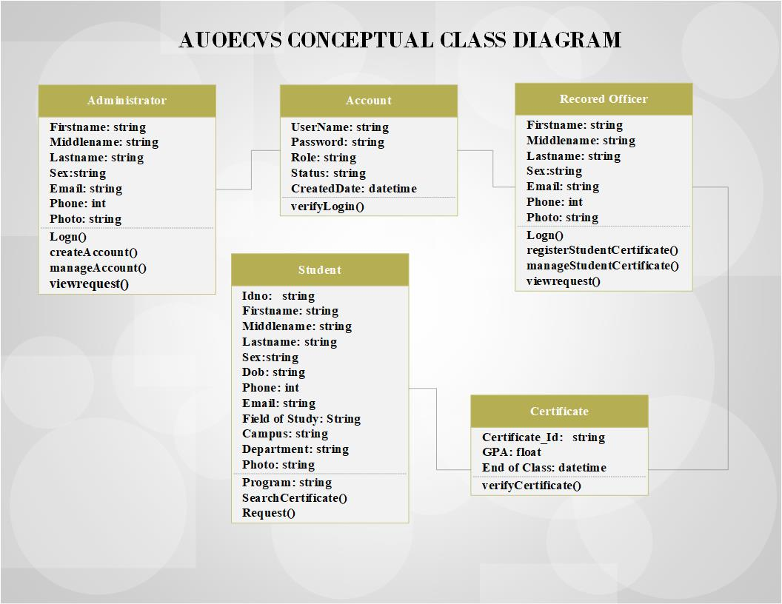Class diagram is a type static structure diagram that describes the structure of a system by showing the system`s classes, their attributes, operations (methods) and the relationships among the classes. Identified classes and their associations for the system is depicted in Figure 4. below.

**Figure 4:**- Conceptual Class diagram of OECVS (UML class diagram). For better readability, we do not show the attributes and operations of the classes.

**4.2.2. Data Dictionary**

The data dictionary is very important as it contains information such as what is in the database, who is allowed to access it, where is the database physically stored etc. The users of the database normally don't interact with the data dictionary; it is only handled by the database administrators.

So In this section mention attributes data type, data size, key constraints and constraints of the identified entities or classes by using tabular form.

|  |  |  |  |  |
| --- | --- | --- | --- | --- |
| **Field Name** | **Data Type** | **Field Size for display** | **Description** | **Example** |
| Username | Varchar | 30 | Unique ID of each account | AE001 |
| Password | varchar | 40 | Password of Account |  |
| Fname | Varchar | 30 | FirstName of the account | Efrata |
| Mname | Varchar | 30 | MiddleName of account | Melkea |
| Lname | Varchar | 30 | LastName of account | Adugna |
| Sex | Varchar | 6 | Gender of account | Female |
| Date of Birth | Date/Time |  | DOB of account | 08/03/1990 |
| Phone Number | Integer | 10 | Phone number of account | 912565884 |
| Role | Varchar | 15 | Role of account | System admin |
| Email | Varchar | 50 | Email of account | [adm@gmail.com](mailto:adm@gmail.com) |
| Status | int |  | Status of account | Enable ,Disable |
| Photo | varchar | 255 | Photo |  |

**Table: - 14 this is a data dictionary describing a table that contains Account details.**

|  |  |  |  |  |
| --- | --- | --- | --- | --- |
| **Field Name** | **Data Type** | **Field Size for display** | **Description** | **Example** |
| Idno | Varchar | 30 | Unique ID of each Student | AUS1900/15 |
| Fname | Varchar | 20 | FirstName of the Student | Efrata |
| Mname | Varchar | 20 | MiddleName of Student | Melkea |
| Lname | Varchar | 30 | LastName of Student | Adugna |
| Sex | Varchar | 6 | Gender of Student | Female |
| Date of Birth | Date/Time | 100 | DOB of Student | 08/03/1990 |
| Phone | Integer | 10 | Phone number of Student | 912565884 |
| Email | Varchar | 100 | Email of Employee | [adm@gmail.com](mailto:adm@gmail.com) |
| CampusName | varchar | 50 | Campus of Student | Megenagna |
| Year | int |  | Starting Year | 2006 |
| Department | varchar | 30 | Department of Student | Computer Science |
| Field of Study | Varchar | 255 | Filed of Study | Belchor of Art |
| Program | Varchar | 25 | Program of Student | Regular |
| Status | Tinyint | 1 | Status of Sudent | Enable Disable |
| Verified | Tinyint | 1 | Verification of Certificate | Verified , Unverified |
| Certificate_ID | Varchar | 255 | Certificate Number of Stdud | AUSC001 |
| GPA | float | 4,2 | GPA of Student | 3.5 |
| EndYear | Date |  | End of Class | 6/9/2012 |
| Photo | varchar | 255 | Photo of Student |  |

**Table: - 15 this is a data dictionary describing a table that contains Student details.**

|  |  |  |  |  |
| --- | --- | --- | --- | --- |
| **Field Name** | **Data Type** | **Field Size for display** | **Description** | **Example** |
| RID | int | 11 | Unique ID of each Request | 1 |
| Offices | Varchar | 25 | Office name of to Request | registrar |
| Messages | Varchar | 30 | Messages of Request | Hi |
| TimeStamp | Timestamp |  | Timestamp of request | 08/03/2019 |
| Status | int | 1 | Status of request | 1 or 0 |

**Table: - 16 this is a data dictionary describing a table that contains Request details**

**4.3. Dynamic Model**

Dynamic model represent the behavior of an object over time. The dynamic model represents the time–dependent aspects of a system. It is concerned with the temporal changes in the states of the objects in a system. In this section we want to describe the behavior of the object model, in terms of sequence, activity and state chart diagrams.

**4.3.1. Sequence Diagram**

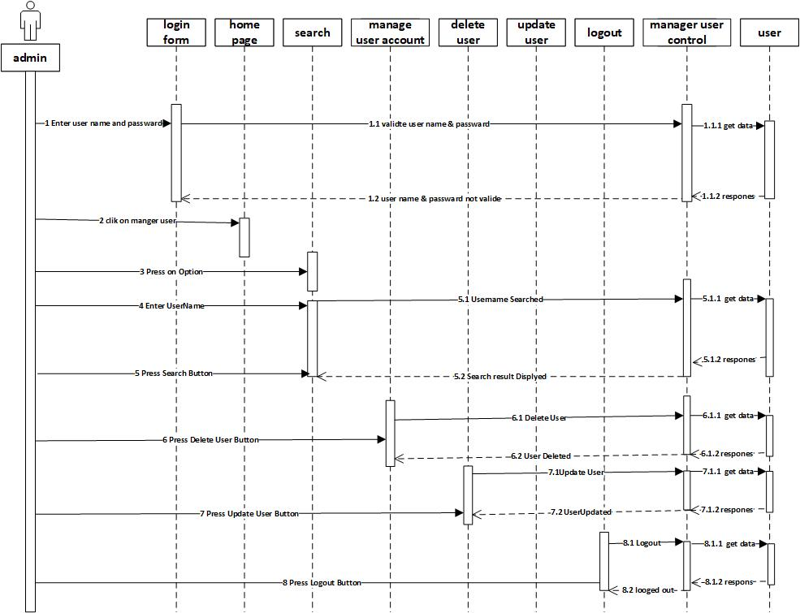Sequence diagram are sometimes is called event diagrams or event scenarios. . In this section we want to illustrate (diagrammatically) a sequential logic, in effect, and the time ordering of messages.

**Figure 5:**- Manage User (UML Sequence diagram)

**4.3.2. Activity Diagram**

Activity diagrams are graphical representations of work flows of stepwise activities and actions with support for choice, iteration and concurrency. In the UML, activity diagrams can be used to describe the business and operational step-by-step work flows of components in a system. An activity diagram shows the overall flow of control from one activity to another and used to document the logic of single operation format.



**Figure 6:**- Manage User (UML Activity diagram).

**4.3.3. State Chart Diagram**

State Chart diagram is a type of diagrams it used to model the dynamic behavior of a model element. In this section we want to define different states of an object during its lifetime and these states are changed by events.

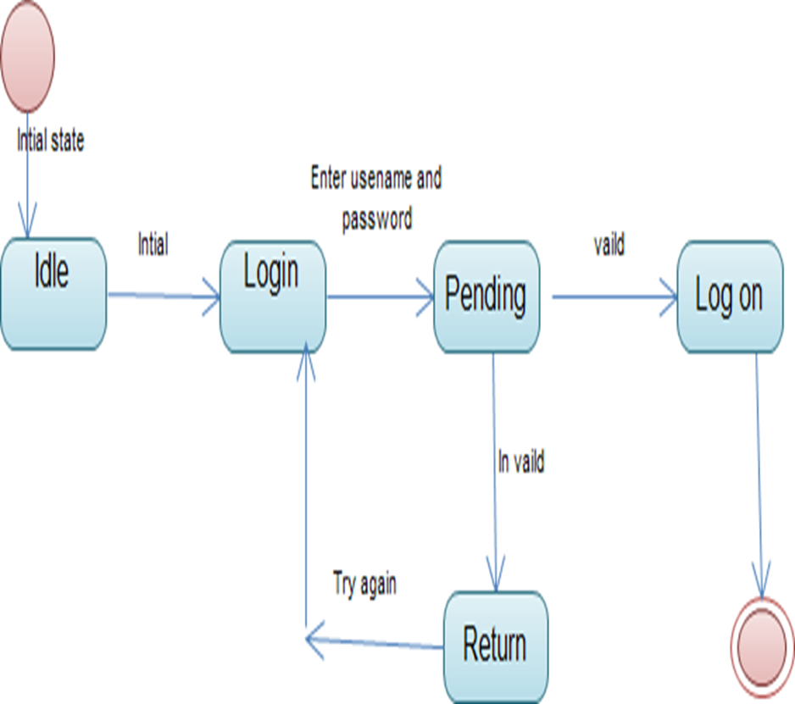

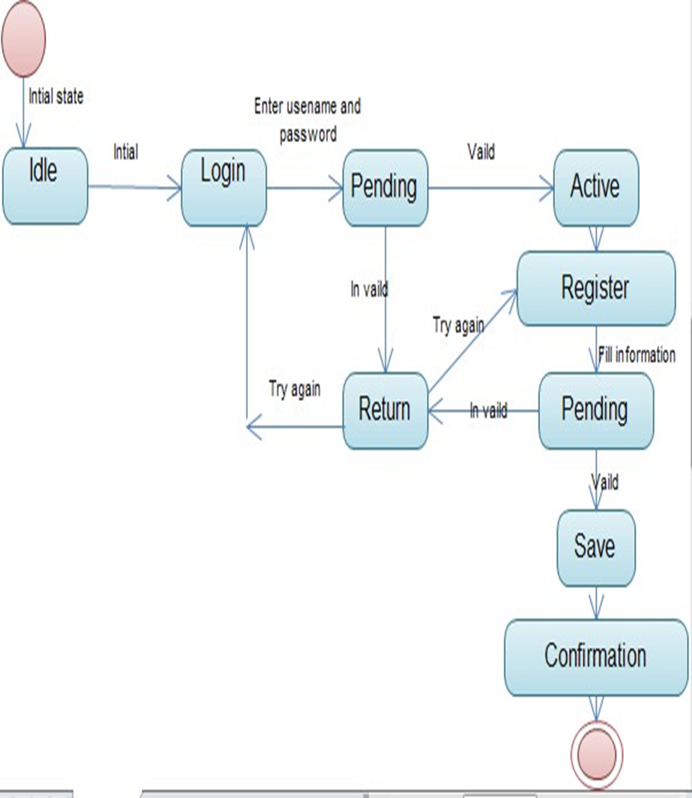**Figure 7:**- User Login (UML State Chart diagram).

**Figure 8:**- Registration Form(UML State Chart diagram).

**CHAPTER FIVE**

**5. SYSTEM DESIGN**

**Introduction**

The purpose of design is to determine how we are going to build the system and to obtain the information needed to drive the actual implementation of our system. It is based on understanding of the model the software built on. The objectives of design are to model the system with high quality. Implementing of high quality system depend on the nature of design created by the designer. If one want to changes to the system after it has been put in to operation depends on the quality of the system design. So if the system is design effectively, it will be easy to make changes to it.

**5.1. Design Goals**

The design goals represent the desired qualities of OECVS and provide a consistent set of criteria that must be considered when making design decisions. And specify the qualities of the system that should be achieved and addressed during the design of the system like:

**5.1.1. Performance**

Performance is mostly response time of the software. Our system response time to searching Educational Certificate verification process gives for customer in less than 100 microseconds.

**5.1.2. Dependability**

The usage of OECVS must be intuitive. The dependability of our system reflects the extent of the user’s confidence that it will operate as users expect and that it will not corrupt data or other systems and will not ‘fail’ in normal use. Users trust a system that is dependable System dependability.

**5.1.3. Maintenance**

Our system is Ease and cost of maintenance such as a simple designed such that any part can be easily changed in and out.

**5.1.4. End user**

End user is used to distinguish the person for whom a hardware or software product is designed from the developers, installers, and servicers of the product.

**5.1.5. Priorities of Design Goal**

The Priorities design goals represent the desired qualities of web based Educational Certificate system and provide a consistent set of criteria that must be considered when making design decisions. Based on non-functionality requirements the following design goals will have to achieve in order to qualify the system as successful.

**5.2. Current System Architecture (if any)**

The online educational verification system project is a Greenfield engineering project. Currently there is no software architecture to replace and the task of OECVS is not accomplished by now. But temporarily the Admas University works in a traditional way that it’s impossible to say a manual system (lack of necessary document) to check Student Certificate that is an organized to work and more time consuming. Including the present of Admas University and other leaders or student connect to each other by phone , letter ,report and every time concerning their works is paper based that to cost for writing materials .

**5.3. Proposed System Architecture**

The propose of this design document is to provide the design models and methodologies that are developed and used to satisfy the requirements. This document presents detailed diagrams that represent the functionality of the system from the system's point of view to provide the necessary interfaces to the users.

In our project we want to avoid this time consuming and boring manual system. In order to overcome this problem, we have planned to design web based online Educational Verification system for every Student.

In today’s computerized world, web based computerized system plays a great role in facilitating works and avoid unnecessary time delaines of services. It enables to access information from anywhere and avoids costs of transportation and others to access information physically like manual system. To make OECVS reachable for as many users as possible, it must be available on the web. The player will not be charged. The project is than financed with University College.

**5.3.1. Subsystem Decomposition and Description**

Subsystem decomposition draws and describes the decomposition into subsystems and the responsibilities of each. This is the main product of system design. Here, use **UML component diagram** to diagrammatically illustrate your components.

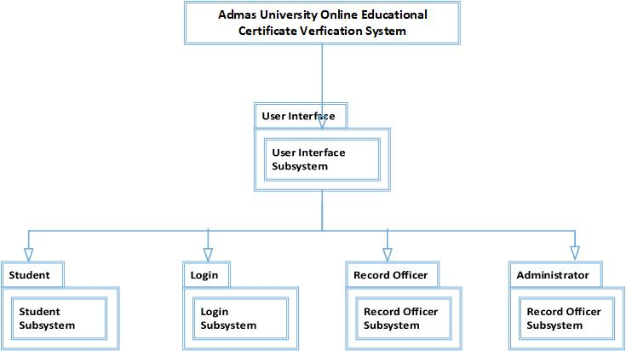

**Figure 9:**- Subsystem decomposition of OECVS (UML diagram). For better understandability.

* **User Interface: -** The UI subsystem consists of classes that are responsible for the graphical user interface to the system user.
* **Login: -** this is a user login interface for logon to the system then which the user can access the system of OECVS using user login page.
* **Student: -** This subsystem to search and verify students’ certificate information details using our system.
* **Record Officer: -** This subsystem to manage all students’ certificate information details. Record officer takes the responsibility of this subsystem by adding new student certificate information detail, updating existing student certificate, deleting unwanted student certificate details.
* **Administrator: -** This subsystem defines how to manage user accounts and system management. This subsystem manages all other subsystems. Administrator is the main actor of this subsystem.

**5.3.2. Hardware/Software Mapping**

Hardware/software mapping describes how subsystems are assigned to hardware and customized components (if any). Here, use **UML deployment diagram** to diagrammatically illustrate the hardware/software mapping.

**OECVS** is built as a Web application and it does communicate to any other internet access area in computer. So, OECVS is an platform independent component that runs on all computer over internet using browser. The following UML deployment diagram illustrates the hardware/software mapping for OCVS.

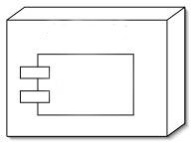

**Client**

**Device**



**Server**

**Device**



**DBMS**

Get Request from online Using browser

Contains

Webserver+

Application Server

Data store in DBMS

**HTTP/HTTPS**

**Figure 10:**- Hardware/Software Mapping of OECVS (UML Object diagram). For better understanding Hardware/software communication.

**5.3.3. Detailed Class Diagram**

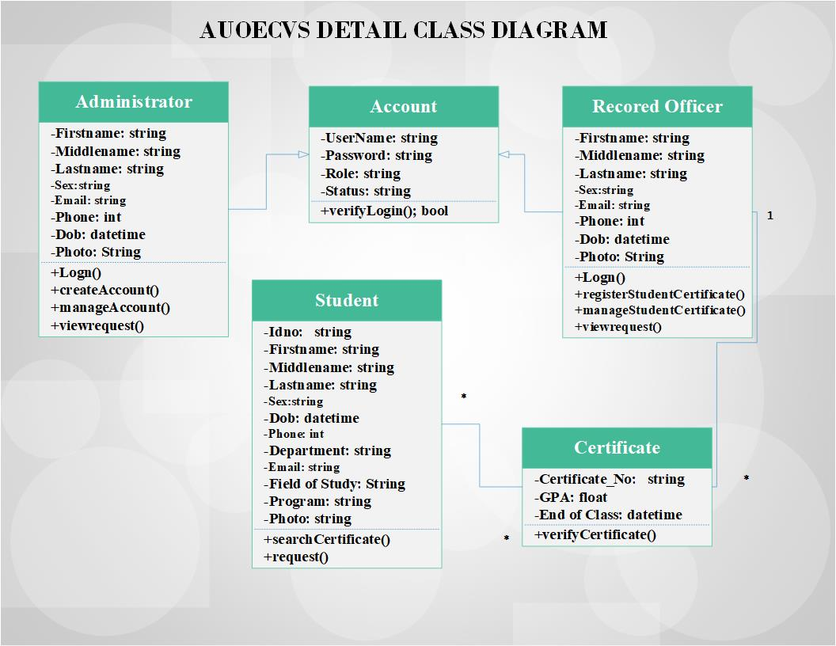Detailed Class Diagram means enhanced diagram of Class diagram. In this section show, classes, attributes, methods, attribute data types, visibility ((Public (+), Private (-), Protected (#)) of attributes and methods), inheritance, association, aggregation, composition, Dependency, and municipality (cardinality and optimality). Here, we use the UML class diagram to specify attributes and operations with their visibility information.

**Figure 11:**- Class diagram of OECVS (UML Detail class diagram). For better readability, we do not show the attributes and operations of the classes. The object model of the RAD provides the classes in more detail.

**5.3.4. Persistent Data Management**

Persistent data management describes the persistent data stored by the system and the data management infrastructure required for it. Database sub system is responsible for all insertion, reading, updating and deletion of all data by all classes within the User login, User management, certificate verification, Certificate Record Management. No data will be accessed in any way except through and by the Database Subsystem. Each class from within the Subsystems described above are responsible for inserting, updating and modifying their own data by utilizing the corresponding methods belonging to the Database Class within the Database Subsystem. Our project requires keeping persistent data about the different user account information to allow different users to have different views of the system and to allow concurrent access to the system, and course related data also need to be recorded and stored in the database including multimedia materials and users activities and account information. For this reason the relational data base management system is chosen as persistent data storage because of its advantages in preserving interrelated data and easy for creating relationships between different entities that can participate in the system. After gathering requirement the to prepare **System analysis** because of system analysis is Application Domain include **Detail Class Diagram,** Detail Class Diagram **is** enhanced Structure of our System then after make a Data Persistent using mapping from Class to Table and each attribute with column carefully.

**Figure 12** Sample Class Diagram

**5.3.5. Access Control and Security**

Access control and security describes the user model of the system in terms of an access privilege. Utilize global access table, describing the access relation between the actors, objects and operations in the system. You can use tables to show the privilege assigned to each users of the system. This section also describes security issues, such as the selection of an authentication mechanism, the use of encryption, and the management of keys.

|  |  |  |
| --- | --- | --- |
| **Sub Systems** | **Access Control** | |
| **User** | **Operation** |
| Account Management | System Administrator | Login, Create Account, Logout, |
| Login, update Account, Logout |
| Login, Delete Account, Logout |
| Database | Record Officers | Login, Insert Records, Logout |
| Login, Update Records, Logout |
| Login, Delete Records, Logout |
| Search | Student | Search Students Education Certificate by their Certificate Number. |
| Certificate Management | Record Officer | Login, Add Student Certificate Information , Logout, |
| Login, update Student certificate, Logout |
| Login, Delete Student Certificate, Logout |
| Request | Student, Administrator, Record Officer | Student Send Request but Record Officer and Administrator View Request |

Table 19 Access Control and Security

**5.4. Packages**

The system will also be available online, and anybody can access the system based on the defined access control.

**5.5. Algorithm Design**

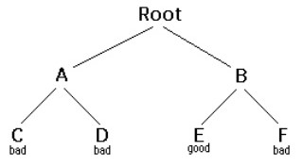Algorithm design it is important to study the process of designing good algorithms for our project problem solving. We use types of strategy algorithm to solve our problem by using backtracking algorithm.

**Figure 13** Backtracking algorithm

**5.6. User Interface Design**

Interface design is the process of putting clear visualization and graphical sample of the designed web application. But now at this time we are not put full user interface here because of not completed user interface design phase at this time. Show simple user interface for our project.

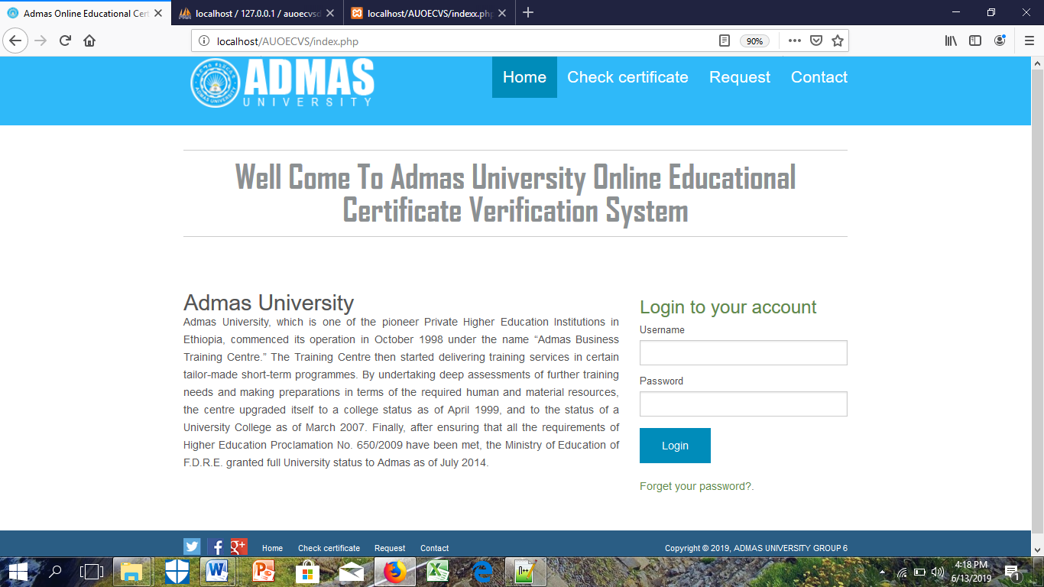

**Figure 14:** Online Educational Verification System Home page User Interface

**CHAPTER SIX**

**6. IMPLEMENTATION AND TESTING**

Systems implementation is the construction of the new system and the delivery of that system into production (that is, the day-to-day business or organization operation). This chapter includes implementing the attributes and methods of each object and integrating all the objects in the system, to function as a single system. and presents user interface design & coding, testing and integrating the system. It involves user-training, system testing in order to ensure successful running of the new system. The user tests the system and changes are made according to their needs. The testing involves evaluating the developed system using various kinds of data. In this part the designs phase is translated into code. In addition to this we would create administrator account to administrator of the whole system, and use the backup devices to protect the system’s records.

**6.1. Implementation of the Database**

Our system database implementation is we used appropriate database management system, that means all tables which were identified and shown as persistent model in the design document should be created with their primary keys, foreign keys, check constraints and unique constraints. Our database normalized from 1st to third normal form for example student table into 3 table normalized for Certificate, Department, Campus and our system Configure a schedule of database backup always backup during logout every system user.

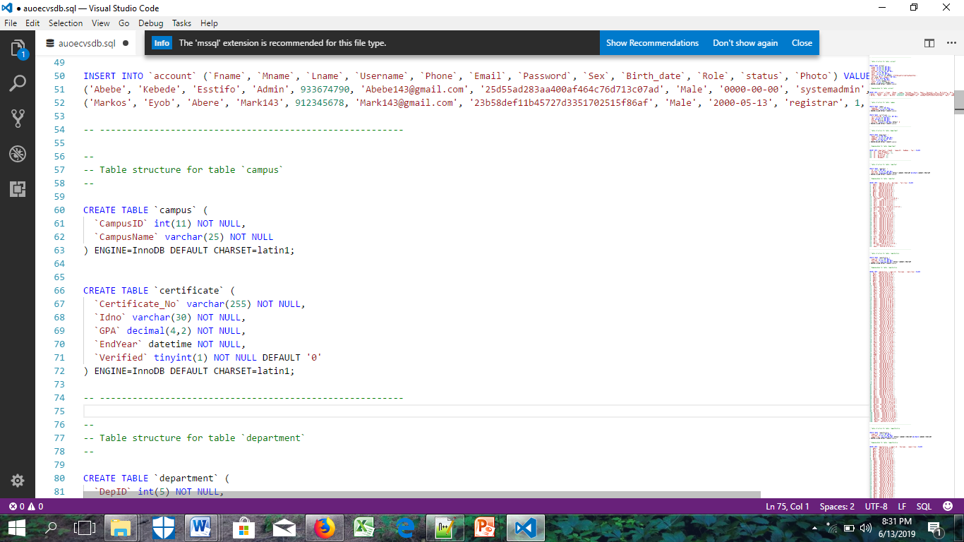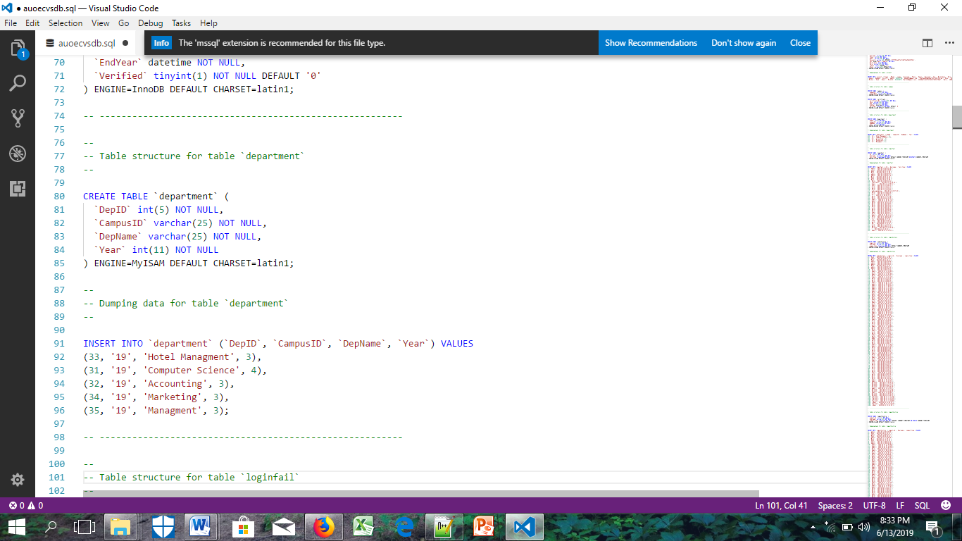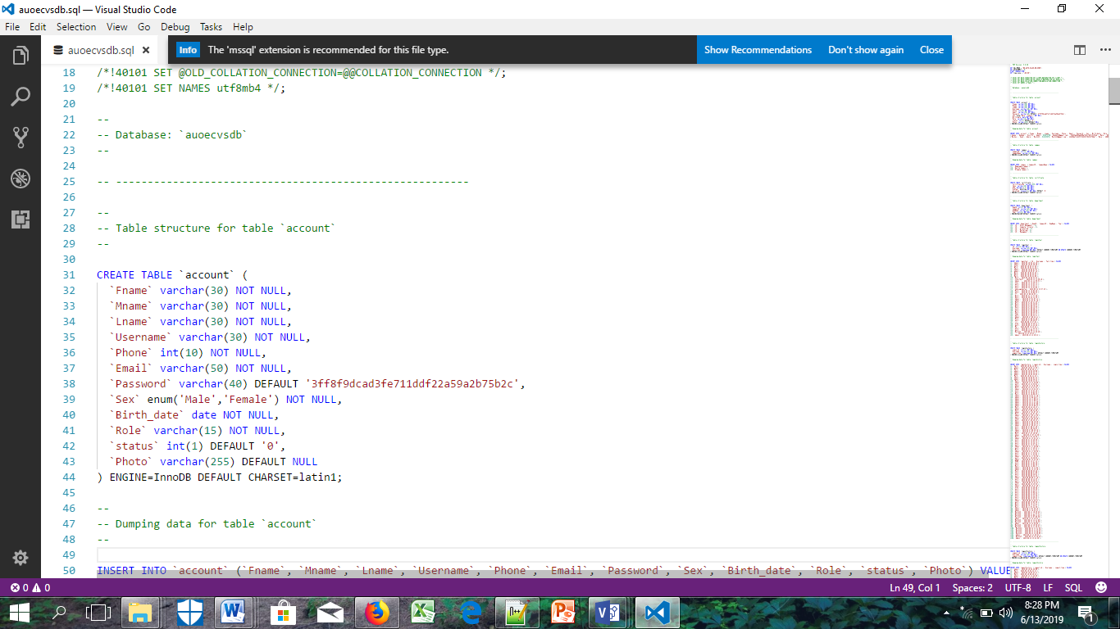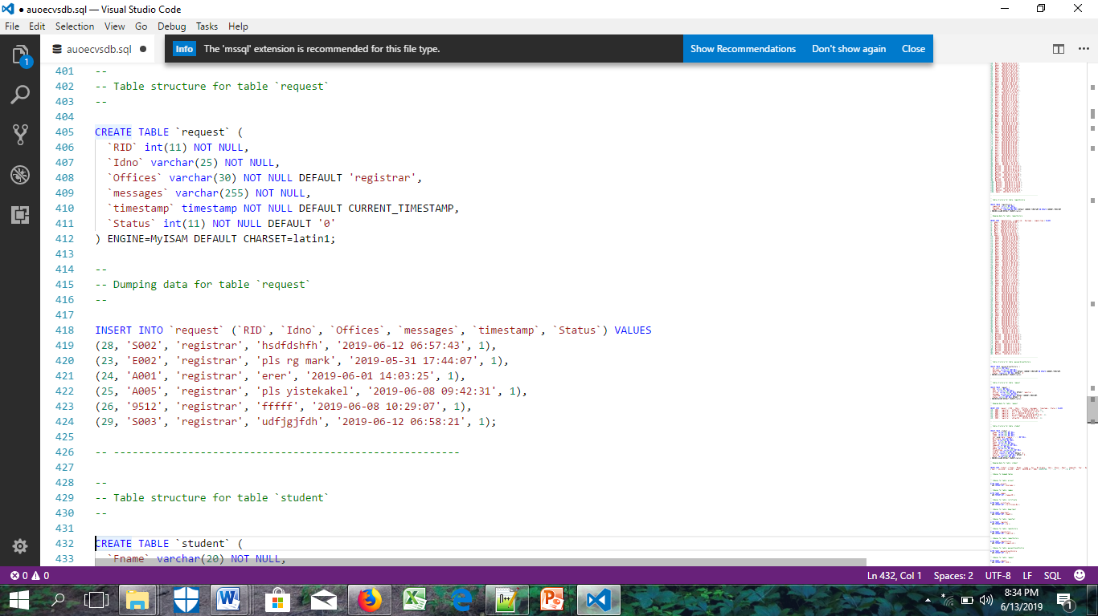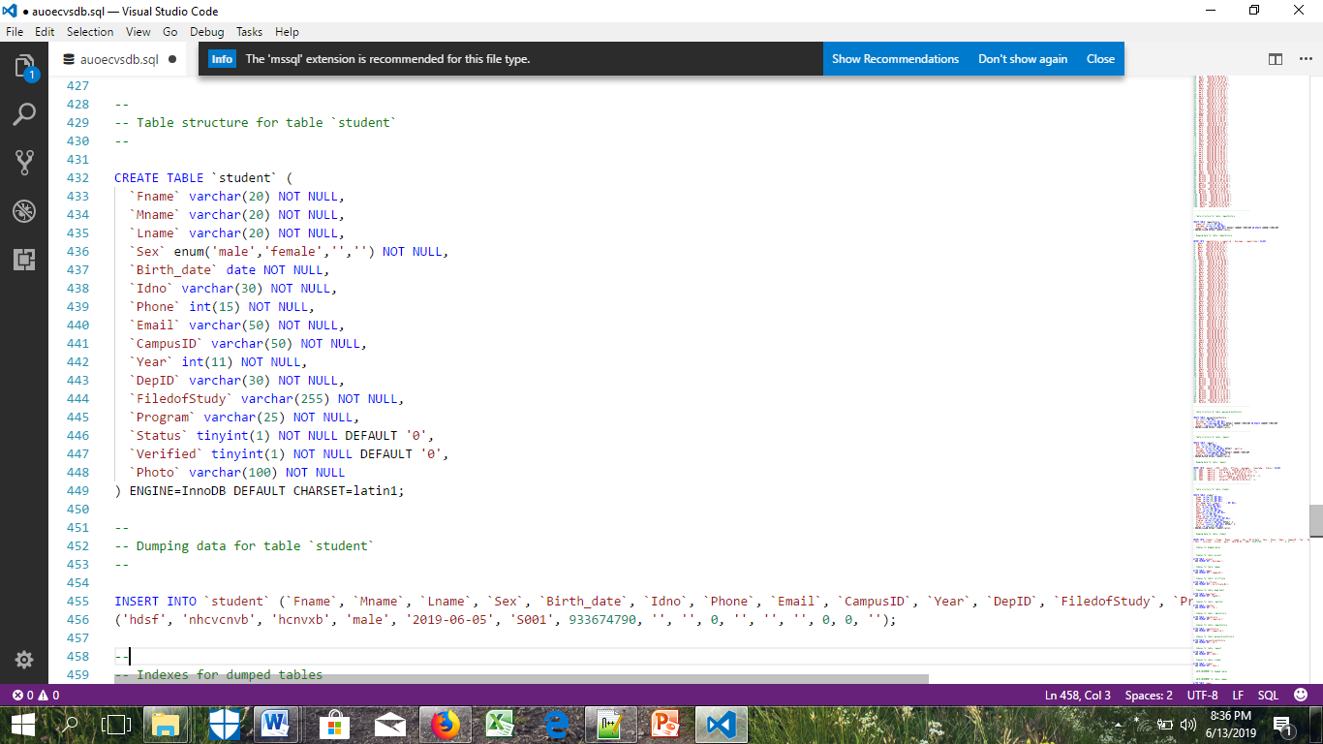

**6.2. Implementation of the Class Diagram**

Implement of our class diagram is in PHP programming language. And an attributes with the appropriate data type Document all our object code with standard comments and implement all the reports as shown on your design document.

**6.3. Configuration of the Application Server**

Here we uses an appropriate application server for their development and clearly justified the reasons about their application server selection. Also, perform the following activities:

1. Properly start and shutdown the application server.
2. Organize AUOECVS folders and files on the server properly.
3. Configure the server to work on the same machine: Able to access contents from the same machine.
4. Configure the server to work on from remote machine: Able to access contents from another/remote machine. we use Temporarily Wireless Network
5. Separation of application server and database we use Xampp Server and Database name AUOECVSDB.
6. Configure the server to work on different port number we use 8080, 3306.

**6.4. Configuration of Application Security**

From the security aspect of our system user, student should take in to account the following tasks.

* We Implement all input validations properly just like **Invalid User Name and Password**
* We Implement **MD5** encryption/decryption
* Roles must be defined clearly
* User accounts must be assigned with necessary access privileges for

**Example: -** Our system user either **Registrar** or **System admin.**

* We implemented Sessions before login and after logout the system.
* Our system none functional requirements in the system feature part we checked.

**6.5. Implementation of User Interface**

User Interface design is the process of putting clear visualization and graphical sample of the designed web application. We design our system user interface is user centered design (Place users in control of the interface) Reduce users’ memory load and the user interface consistent. Show simple user interface from our project.

* **Home page**

The home page can display in the homepage our system and In additional It contains the login form to login system user and other Menu hyper link like Check certificate, Request, Contact.



Desktop View

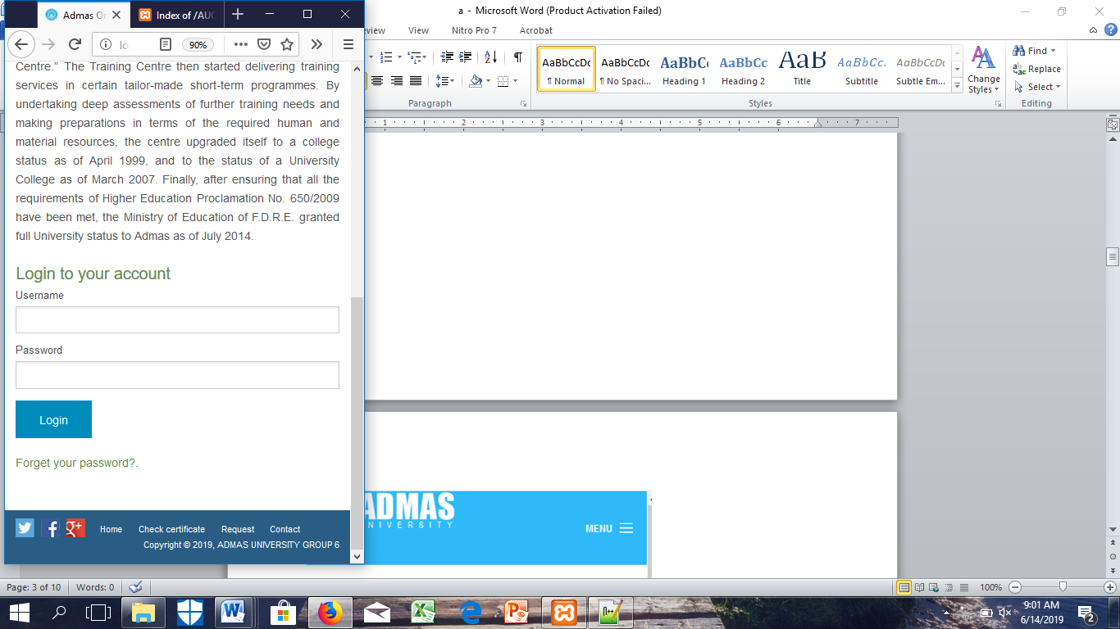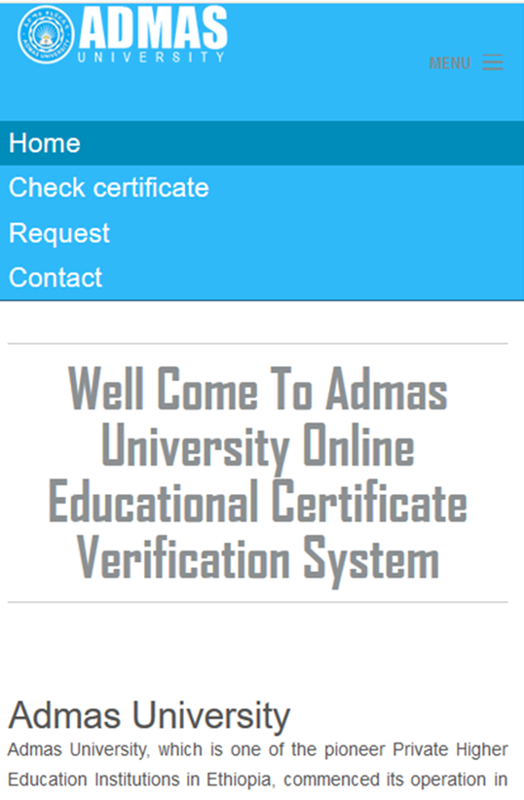

Mobile View

**Figure 15:** Online Educational Verification System Home page User Interface

* **Check Certificate**

The Check Certificate Page can display in the Check Certificate textbox and Search Button it used to check and verify Every Educational Certificate after graduation for Admas University Student. by using Certificate Number.

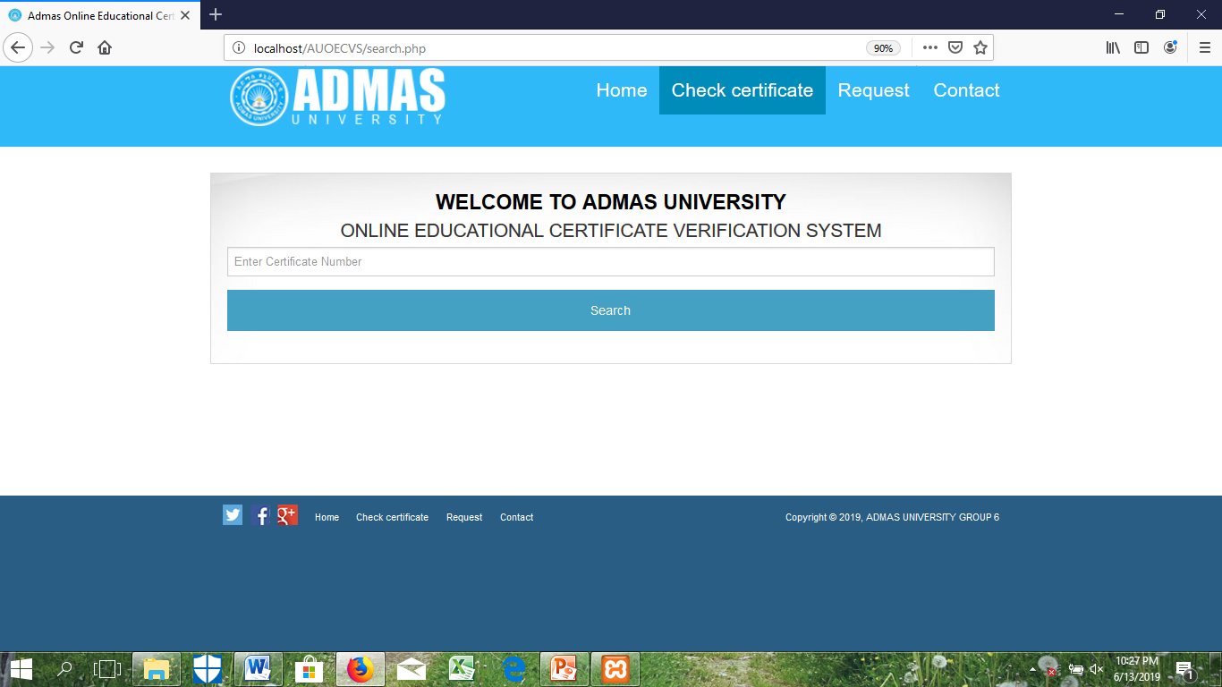

Desktop View

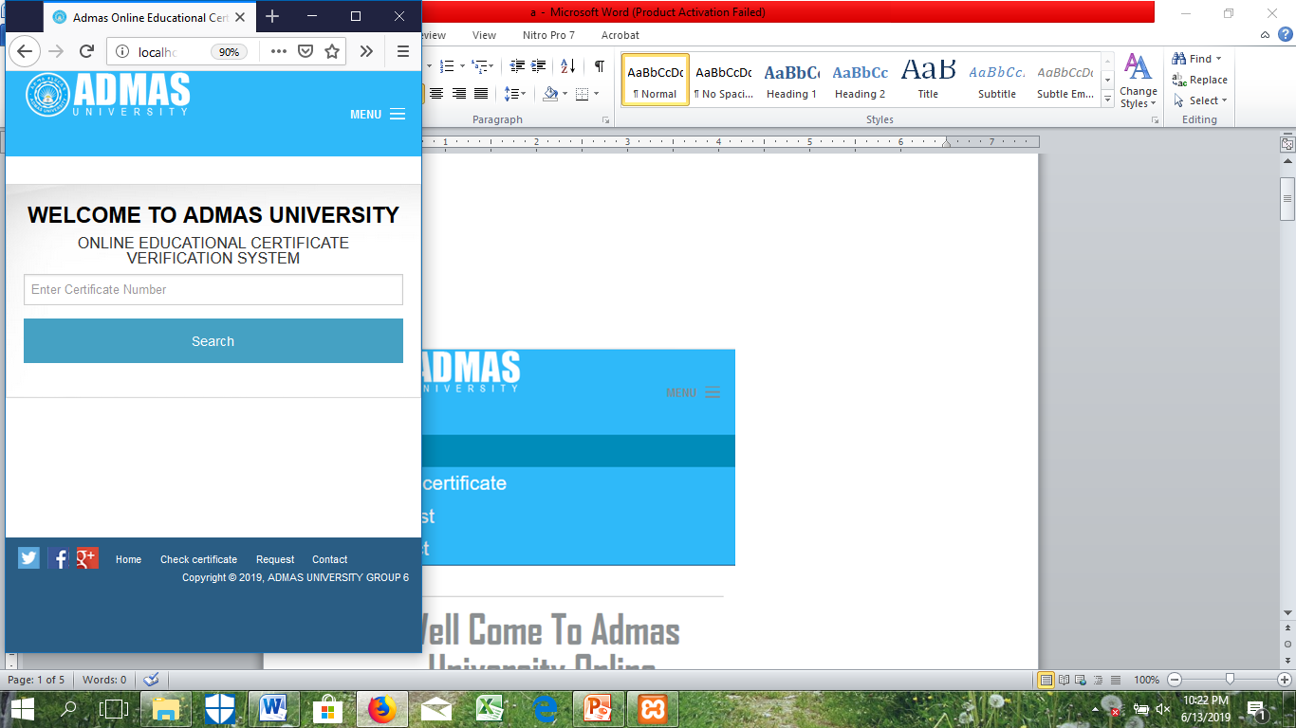

Mobile View

**Figure 16:** Online Educational Verification System Check Certificate User Interface

**6.6. Testing**

The testing involves evaluating the developed system using various kinds of data. In this part the designs phase is translated into code. In addition to this we would create administrator account to administrator of the whole system, and use the backup devices to protect the system’s records. There were different types of testing strategies such as unit testing, integration testing, system testing, user acceptance testing.

**6.6.1. Testing Tools and Environment**

**6.6.2. Unit Testing**

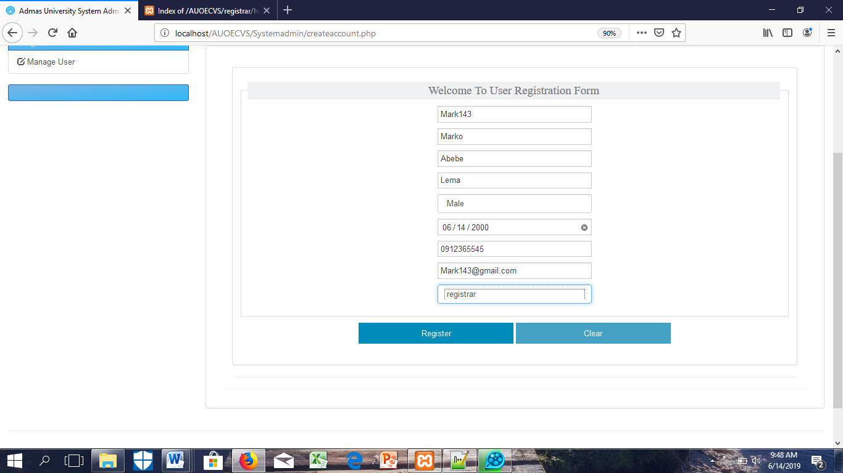Unit testing a type of testing it performed on each module or block of code during development. Unit testing is normally done by the programmer who writes the code. This inform to the user to re-enter valid data input. In this case all the modules of the system are functional and accept valid data input. Every module of the System is going to be separately tested. I.e. the team tested every module by applying some selection mechanism. Through this mechanism every modules gets tested. If an error occurs, correction has been taken without affecting another module. Therefore, the group tested for the individual units of source code assigned areas. We used test data that is different from the test data of the quality assurance team.

Figure 17: The system admin create account fill every filled on the given form

**6.6.3. System Testing**

System testing is our system by using testing procedures where the testing team tests the system as a whole.so for this project our advisor acts as a testing team for testing the system. Once all the components were integrated, the application as a whole was tested rigorously to see that it meets the specified Quality Standards.

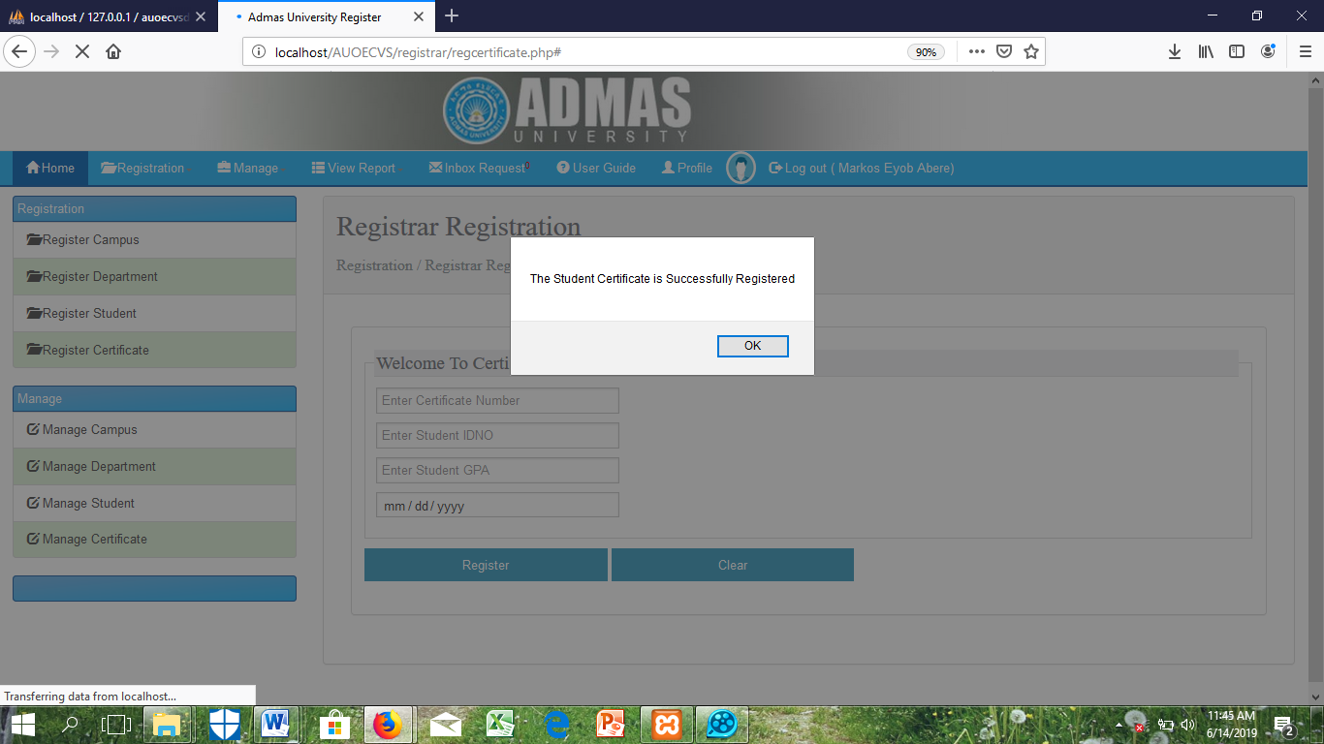

Figure 18: The Registrar Register Certificate fill every filled on the given form

**6.6.4. Integration Testing**

The group members have tested for the combined parts of an application to determine if it functions correctly. The integration testing is done in two ways: Bottom-up integration testing and Top-down integration testing.

* **Bottom-Up Integration: -** In this testing we began from unit testing, followed by tests of progressively higher-level combinations of units called modules or builds.
* **Top-Down Integration: -** We have tested highest-level modules in the first stage and progressively, lower-level modules were tested then after.

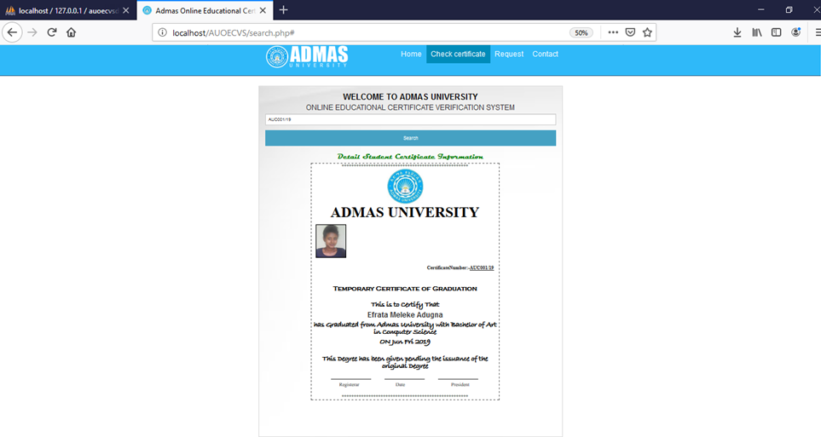

Figure 19: The system admin create account fill every filled on the given form

**6.6.5. Acceptance Testing**

Acceptance testing is the system must be done after installation and any module in the system is acceptance the input by their necessarily steps .some of modules are log in, student Certificate registration, user registration, and etc.

**CHAPTER SEVEN**

1. **CONCLUSION AND RECOMMENDATION**

Matching of the conclusions with the objectives framed and fulfillment of the objectives are taking into consideration in this part. Further scope and further enhancement of the work done also indicated here.

* 1. **Conclusion**

Admas University Online Educational Certificate Verification System is the new System for admas university because it uses to check and verify every student educational certificate in manual system. Our team initiated to implement Online Educational Certificate Verification System that enable student to manipulate students Certificate information in simpler and comfortable manner by minimizing burden of registrar officer and avoid boring manual Certificate verification system .The system enables the organization to process student information in faster, reliable, secure, and flexible manner. For security purpose the system have two classes of users, namely the administrative level and registrar user level. The administrator, which if the manager of the registrar office has higher class of privilege for controlling the system, and registrar users which includes students certificate information and record officer have limited access in the system according to their own privilege. Our System End users access the database through the internet and can perform certain transactions according to their authorization. The system implementation and structured and reliable information, quick and remote access, and prompt updating capabilities. in comparison with the manual System, the benefit under a computer system considerable in to saving of manpower, working hour and efforts. It can observe that the information required can be obtained with ease and accuracy in the computerized system. The user with minimum knowledge about computer can be able Operate the system easily. Various validation techniques have been used to implement Accuracy of data in all formats of input. This software can be used by any university as it can be modified easily; additional Features can be added without interrupting the normal functioning of the system.

* 1. **Recommendation**

To accomplish all works that we have written in this paper we have used different methods to understand the drawback of the current system, failure of the current system and advantages of using the new computerized system. So the team recommends the organization department to start the new system starting from this year.

We have many reasons which force us to develop these check online educational certificate system. The problems were stated under the proposal and this project would definitely solve the problem. Therefore we recommend the organization implement this system on the existing system.

Since the webpage is dynamic it is easy to update. Therefore the organization can update it at any time and start different services. So as a recommendation the team recommend the department to start using both systems. (That was the existing system and the new system).

* 1. **REFERENCES**

[1]. Ali Bahrami, Object oriented systems development (1999 G.C),

[2]. http://www.admasuniversity.edu.et/directory/assosa-university/1004/, retrieved on November 23, 2008 E.C

[3]. [http://www.deftinfosystems.com/index.php/application/e-education-system/online- examination-system.html](http://www.deftinfosystems.com/index.php/application/e-education-system/online-examination-system.html), retrieved on November 12, 2008 E.C

[4]. http://[www.scribd.com/doc/33852099/on-line-examiniation-system-project-report](http://www.scribd.com/doc/33852099/on-line-examiniation-system-project-report), retrieved on November 18, 2008 E.C.

[5]. Jeffery A. eta’l “Modern systems analysis and design” (2005 G.C).

[6]. http://www.W3schools.com, 2019 G.C

* 1. **APPENDICES**
     1. **Appendix A: Interview and Questionnaires (if any)**

1. Who is the main user of the system?
2. Who obtain information from the system?
3. Who provides information to the system?
4. How many employees in registrar are there?
5. How many Students ask to check own certificate from registrar office?
6. Who are the main players (Actors) of the system?
7. What are the problems in current system to Check and verify Student Certificate, especially in giving services?
8. How many Departments are there?
9. How many campus are there?
10. How many Programs are there?
11. Do you have sample forms of Student registration and Certificate form?
12. What are the responsibilities of registrar?
13. What are the responsibilities of student?
14. What is your vision in the future as of your organization?
15. Do you have any report form?
16. What are the business rules of the organization with respect to Online Educatioal Certificate Verification System?
    * 1. **Appendix B: Existing System Forms and Reports**
17. **Forms and Other Documents of the Existing Systems (if any)**





* + 1. **Appendix C: Sample Source Code**

1. Login Code

<?php

//Start session

session_start();

if(isset($_POST['login'])){

    //Connect to mysql server

    include_once("db_config/dbconfig.php");

    //retrieving username and password from the form and store into variables.

    $username=$_POST['username'];

    $password=md5($_POST['password']);//md5 encription code use

    //checking username and password in the database

    $sql = "select * from account where Username='$username' and password='$password'";

$query = mysqli_query($con, $sql);

    //to count number of rows

    $result=mysqli_num_rows($query); //

    if($result>0)

    {

        while($row = mysqli_fetch_array($query))

{

$user_role= $row['Role'];

                         $usr= $row['Username'];

                         $pss= $row['Password'];

                         $stat= $row['status'];

}

                                        if($stat==1)

                                        {

                                            if($user_role=='registrar')

                                            {

                                            //session stored

                                            $_SESSION['SESS_MEMBER_ID'] = $pss;

             $_SESSION['SESS_FIRST_NAME'] = $usr;

                                            session_write_close();

                                            //Login History Add

                                            $sql1=mysqli_query($con,"Insert into loginhistory(Username)values('$username')");

                                            header('Location:registrar/registrar.php');

                                            exit();

                                            }

                                            elseif($user_role=='systemadmin')

                                            {

                                            $_SESSION['SESS_MEMBER_ID'] = $pss;

             $_SESSION['SESS_FIRST_NAME'] = $usr;

                                            session_write_close();

                                            $sql1=mysqli_query($con,"Insert into loginhistory(Username)values('$username')");

                                            header("Location: Systemadmin/systemadmin.php");

                                            exit();

                                            }

                                            else

                                            {

                                                //loginfail Add

                                                $sql1=mysqli_query($con,"Insert into loginfail(Username)values('$username')");

     ?>

                                     <script>

alert('YOUR USER NAME AND PASSWORD IS NOT MATCH WITH YOUR ROLE Tray again');

window.location='index.php';

</script>

                                 <?php

                                            }

}

                                        else

                                        {

$sql1=mysqli_query($con,"Insert into loginfail(Username)values('$username')");

                                        ?>

                                         <script>

alert('Your account is disabled Please Contact the Administrator!!! and Tray again');

window.location='index.php';

</script>

                                     <?php

                                     }

                                }

else

{

                                $sql1=mysqli_query($con,"Insert into loginfail(Username)values('$username')");

?>

                                    <script>

alert('Incorrect USER NAME or PASSWORD Pls match and Try again ');

window.location='index.php';

</script>

                                <?php

                            }

}

?>

1. Check Certificate Code

<!--

======================Group Member==========================

Fullname ID

1. Efrata Melekea Adugna........................1900/15

2. Aschalew Abebe...............................1673/15

3. Eman Hashim...................................2385/15

4. Medhin Mehari.................................0348/15

-->

<!-- Admas University online Educational Certificate verification System Code-->

<?php

//Include Database Connection from Db_Config folder

include('db_config/dbconfig.php');

?>

<?php

session_start();

//require_once 'db_config/dbconfig.php';

?>

<html>

<head>

<meta charset="utf-8">

<!-- Always force latest IE rendering engine or request Chrome Frame -->

<meta content="IE=edge,chrome=1" http-equiv="X-UA-Compatible">

<meta name="viewport" content="width=device-width, initial-scale=1.0" />

<!-- This is Titile of This Web Page -->

<title>Admas Online Educational Certificate Verification System</title>

<!-- This is Keyword to Search on Using like Google search engine---->

<meta name="description" content="Admas University OECVS is an easy to check and verify each student educational certificate." />

<meta name="keywords" content="Admas, OECVS" />

<!-- This is stylesheet link from External Stylesheet -->

<link href="css/style.css" rel="stylesheet" type="text/css" />

<!-- This is Icon of Our Webpage link from Images folder -->

<link href="images/logo.png" rel="icon" type="image/png" />

</head>

<!-- index class in body -->

<body class="index">

<div class="contain-to-grid">

<!-- Navigation Class Top Bar -->

<nav class="top-bar" data-topbar>

<ul class="title-area">

<li class="name">

<h1><a href="index.php"><img src="images/admas-logo.png" width="284" height="74"></a></h1>

</li>

<li class="toggle-topbar menu-icon">

<a href="#">

<span>Menu</span>

</a>

</li>

</ul>

<!-- In Navigation Class Section class top-bar-section -->

<section class="top-bar-section">

<!-- Right Class Navigation in Section class top-bar-section -->

<ul class="right">

<li class=""><a href="index.php">Home</a></li>

<li class="active"><a href="search.php">Check certificate</a></li>

<li class=""><a href="request.php">Request</a></li>

<li class=""><a href="contact.php">Contact</a></li>

<!--<li class=""><a href="login.php">Login</a></li>!-->

</ul>

</section>

</nav></div>

<!-- Wrapper id,here class,row class, -->

<div id="wrapper">

<div class="hero">

<div class="row">

</div>

<!-- Form-banner id -->

<div id="form-banner" class="row panel">

<div class="row">

<div class="large-12 columns">

<h2>WELCOME TO ADMAS UNIVERSITY</h2>

<h4>ONLINE EDUCATIONAL CERTIFICATE VERIFICATION SYSTEM</h4>

<form name="" method="post" action="#">

<input type="text" name="cid" placeholder="Enter Certificate Number" required>

<input type="submit" class="success button expand" name="search" value="Search"/>

</form>

</div>

</div>

<?php

if(isset($_POST['search']))

{

$d=$_POST['cid'];

$sql="select * from Student,Certificate,Department Where Student.Idno=Certificate.Idno and Certificate_No='$d' and Student.DepID=Department.DepID";

$query=mysqli_query($con,$sql);

if(mysqli_num_rows($query)>0)

{

while($row=mysqli_fetch_array($query))

{

$cno=$row["Certificate_No"];

$Fname=$row["Fname"];

$Mname=$row["Mname"];

$Lname=$row["Lname"];

$gdate=$row["EndYear"];

$FiledofStudy=$row["FiledofStudy"];

$Department=$row["DepName"];

$gdate=strtotime($gdate);

$gdate=date('M D Y');

$verify=$row["Verified"];

$pic="<img src='registrar/uploads/studentphoto/$row[Photo]' width=100 height=110 style=' width: 100px; height:110px; margin-left:15px; border:1px solid Black;'";

}

if($verify!='0')

{

?>

<h3 class="panel-title"><font color="Green" face="Magneto">Detail Student Certificate Information</font></h3>

<div class="form-banner" style="font-family: times new roman;" >

<div id="form-banner" style=" width: 620px; margin-left: 150px;">

<div style="border: dashed;background: white;">

<center>****************************************************<br />

<img src="images/Picture1.jpg" title="Admas University Logo"width="120" height="120"></br><font color="Black" size="8px" face="CASTLLAR"><b>ADMAS UNIVERSITY</br></b></font>

</br>

<p align="left">

<?php echo "$pic";?></p>

<p align="right"><?php echo '<b>CertificateNumber:-<u>'."$cno".'</u></b>';?>&nbsp;&nbsp;&nbsp;&nbsp;</p>

<div class="sizeprint2">

<h3><font color="Black" face="Copperplate Gothic Light"><b><br>Temporary Certificate of Graduation</br></b></font></h3>

<h4><font color="Black" face="Bradley Hand ITC" ><b><br>This is to Certify That</b></font></h3>

<?php echo '<b><h4>'.$Fname.'&nbsp;'.$Mname.'&nbsp;'.$Lname.'</u></b></h4>'; ?>

<h4><font color="Black" face="Bradley Hand ITC" ><b>has Graduated from Admas University with <?php echo "$FiledofStudy";?> in <?php echo "$Department";?></br></b></font></h4>

<h4><font color="Black" face="Bradley Hand ITC" ><b>ON <?php echo "$gdate";?></br></b></font></h4>

<h4><font color="Black" face="Bradley Hand ITC" ><b><br>This Degree has been given pending the issuance of the original Degree</b></font></h4>

</center>

<p align="left">&nbsp;&nbsp;&nbsp;&nbsp;&nbsp;&nbsp;&nbsp;&nbsp;&nbsp;&nbsp;&nbsp;&nbsp;&nbsp;&nbsp;&nbsp;&nbsp;<u>&nbsp;&nbsp;&nbsp;&nbsp;&nbsp;&nbsp;&nbsp;&nbsp;&nbsp;&nbsp;&nbsp;&nbsp;&nbsp;&nbsp;&nbsp;&nbsp;&nbsp;&nbsp;&nbsp;&nbsp;&nbsp;&nbsp;&nbsp;&nbsp;&nbsp;&nbsp;&nbsp;&nbsp;&nbsp;&nbsp;&nbsp;&nbsp;&nbsp;</u>

&nbsp;&nbsp;&nbsp;&nbsp;&nbsp;&nbsp;&nbsp;&nbsp;&nbsp;&nbsp;<u>&nbsp;&nbsp;&nbsp;&nbsp;&nbsp;&nbsp;&nbsp;&nbsp;&nbsp;&nbsp;&nbsp;&nbsp;&nbsp;&nbsp;&nbsp;&nbsp;&nbsp;&nbsp;&nbsp;&nbsp;&nbsp;&nbsp;&nbsp;&nbsp;&nbsp;&nbsp;&nbsp;&nbsp;&nbsp;&nbsp;&nbsp;&nbsp;&nbsp;</u>

&nbsp;&nbsp;&nbsp;&nbsp;&nbsp;&nbsp;&nbsp;&nbsp;&nbsp;&nbsp;<u>&nbsp;&nbsp;&nbsp;&nbsp;&nbsp;&nbsp;&nbsp;&nbsp;&nbsp;&nbsp;&nbsp;&nbsp;&nbsp;&nbsp;&nbsp;&nbsp;&nbsp;&nbsp;&nbsp;&nbsp;&nbsp;&nbsp;&nbsp;&nbsp;&nbsp;&nbsp;&nbsp;&nbsp;&nbsp;&nbsp;&nbsp;&nbsp;&nbsp;</u><br>

&nbsp;&nbsp;&nbsp;&nbsp;&nbsp;&nbsp;&nbsp;&nbsp;&nbsp;&nbsp;&nbsp;&nbsp;&nbsp;&nbsp;&nbsp;&nbsp;&nbsp;&nbsp;&nbsp;&nbsp;&nbsp;&nbsp;&nbsp;Registerar&nbsp;&nbsp;&nbsp;&nbsp;&nbsp;&nbsp;&nbsp;&nbsp;&nbsp;&nbsp;&nbsp;&nbsp;&nbsp;&nbsp;&nbsp;&nbsp;&nbsp;&nbsp;&nbsp;&nbsp;&nbsp;&nbsp;&nbsp;&nbsp;&nbsp;&nbsp;&nbsp;&nbsp;&nbsp;&nbsp;Date

&nbsp;&nbsp;&nbsp;&nbsp;&nbsp;&nbsp;&nbsp;&nbsp;&nbsp;&nbsp;&nbsp;&nbsp;&nbsp;&nbsp;&nbsp;&nbsp;&nbsp;&nbsp;&nbsp;&nbsp;&nbsp;&nbsp;&nbsp;&nbsp;&nbsp;&nbsp;&nbsp;&nbsp;&nbsp;&nbsp;&nbsp;&nbsp;&nbsp;&nbsp;&nbsp;&nbsp;&nbsp;President</p>

<center>****************************************************<br /></center>

<?php

}else

echo '<h3><img src="images/invalid.png" width="40" height="40">&nbsp;&nbsp;<font color="red">Your Certificate is Not Verified form the registrar <br />Please contact the registrar again.</font></h3>"';

}// 2nd if

else

{

echo '<h3><img src="images/invalid.png" width="40" height="40">&nbsp;&nbsp;<font color="red">Your Certificate Number is Invalid form the registrar <br />Please contact the registrar again.</font></h3>';

}

}// first if?>

</div>

</div>

</div>

<!--

======================Group Member==========================

Fullname ID

1.  Efrata Melekea Adugna........................1900/15

2.  Aschalew Abebe...............................1673/15

3.  Eman Hashim...................................2385/15

4.  Medhin Mehari.................................0348/15

-->

<!-- Admas University online Educational Certificate verification System Code-->

<?php

//Include Database Connection from Db_Config folder

include('db_config/dbconfig.php');

?>

<?php

session_start();

//require_once 'db_config/dbconfig.php';

?>

<html>

<head>

<meta charset="utf-8">

<!-- Always force latest IE rendering engine or request Chrome Frame -->

<meta content="IE=edge,chrome=1" http-equiv="X-UA-Compatible">

<meta name="viewport" content="width=device-width, initial-scale=1.0" />

<!-- This is Titile of This Web Page -->

<title>Admas Online Educational Certificate Verification System</title>

  <!-- This is Keyword to Search on Using like Google search engine---->

<meta name="description" content="Admas University OECVS is an easy to check and verify each student educational certificate." />

<meta name="keywords" content="Admas, OECVS" />

  <!-- This is stylesheet link from External Stylesheet -->

<link href="css/style.css" rel="stylesheet" type="text/css" />

  <!-- This is Icon of Our Webpage link from Images folder -->

<link href="images/logo.png" rel="icon" type="image/png" />

</head>

<!-- index class in body -->

<body class="index">

  <div class="contain-to-grid">

   <!-- Navigation Class Top Bar -->

<nav class="top-bar" data-topbar>

<ul class="title-area">

<li class="name">

<h1><a href="index.php"><img src="images/admas-logo.png" width="284" height="74"></a></h1>

</li>

<li class="toggle-topbar menu-icon">

<a href="#">

<span>Menu</span>

</a>

</li>

</ul>

     <!-- In Navigation Class Section class top-bar-section -->

<section class="top-bar-section">

<!-- Right Class Navigation in Section class top-bar-section -->

<ul class="right">

<li class=""><a href="index.php">Home</a></li>

       <li class="active"><a href="search.php">Check certificate</a></li>

<li class=""><a href="request.php">Request</a></li>

       <li class=""><a href="contact.php">Contact</a></li>

<!--<li class=""><a href="login.php">Login</a></li>!-->

</ul>

</section>

</nav></div>

<!-- Wrapper id,here class,row class, -->

<div id="wrapper">

  <div class="hero">

     <div class="row">

     </div>

     <!-- Form-banner id -->

     <div id="form-banner" class="row panel">

     <div class="row">

      <div class="large-12 columns">

       <h2>WELCOME TO ADMAS UNIVERSITY</h2>

       <h4>ONLINE EDUCATIONAL CERTIFICATE VERIFICATION SYSTEM</h4>

       <form name="" method="post" action="#">

        <input type="text" name="cid" placeholder="Enter Certificate Number" required>

        <input type="submit" class="success button expand" name="search" value="Search"/>

      </form>

      </div>

     </div>

<?php

              if(isset($_POST['search']))

{

$d=$_POST['cid'];

$sql="select * from Student,Certificate,Department Where Student.Idno=Certificate.Idno and Certificate_No='$d' and Student.DepID=Department.DepID";

$query=mysqli_query($con,$sql);

                  if(mysqli_num_rows($query)>0)

{

while($row=mysqli_fetch_array($query))

{

                     $cno=$row["Certificate_No"];

                     $Fname=$row["Fname"];

                     $Mname=$row["Mname"];

                     $Lname=$row["Lname"];

                     $gdate=$row["EndYear"];

                     $FiledofStudy=$row["FiledofStudy"];

                     $Department=$row["DepName"];

                     $gdate=strtotime($gdate);

                     $gdate=date('M D Y');

                     $verify=$row["Verified"];

                     $pic="<img src='registrar/uploads/studentphoto/$row[Photo]' width=100 height=110 style=' width: 100px; height:110px; margin-left:15px; border:1px solid Black;'";

                   }

                   if($verify!='0')

                    {

?>

  <h3 class="panel-title"><font color="Green" face="Magneto">Detail Student Certificate Information</font></h3>

<div class="form-banner" style="font-family: times new roman;" >

<div id="form-banner" style=" width: 620px; margin-left: 150px;">

<div style="border: dashed;background: white;">

<center>****************************************************<br />

<img src="images/Picture1.jpg" title="Admas University Logo"width="120" height="120"></br><font color="Black" size="8px" face="CASTLLAR"><b>ADMAS UNIVERSITY</br></b></font>

</br>

<p align="left">

<?php echo "$pic";?></p>

<p align="right"><?php echo '<b>CertificateNumber:-<u>'."$cno".'</u></b>';?>&nbsp;&nbsp;&nbsp;&nbsp;</p>

<div class="sizeprint2">

   <h3><font color="Black" face="Copperplate Gothic Light"><b><br>Temporary Certificate of Graduation</br></b></font></h3>

   <h4><font color="Black" face="Bradley Hand ITC" ><b><br>This is to Certify That</b></font></h3>

<?php echo '<b><h4>'.$Fname.'&nbsp;'.$Mname.'&nbsp;'.$Lname.'</u></b></h4>'; ?>

    <h4><font color="Black" face="Bradley Hand ITC" ><b>has Graduated from Admas University with <?php echo "$FiledofStudy";?> in <?php echo "$Department";?></br></b></font></h4>

    <h4><font color="Black" face="Bradley Hand ITC" ><b>ON <?php echo "$gdate";?></br></b></font></h4>

<h4><font color="Black" face="Bradley Hand ITC" ><b><br>This Degree has been given pending the issuance of the original Degree</b></font></h4>

    </center>

    <p align="left">&nbsp;&nbsp;&nbsp;&nbsp;&nbsp;&nbsp;&nbsp;&nbsp;&nbsp;&nbsp;&nbsp;&nbsp;&nbsp;&nbsp;&nbsp;&nbsp;<u>&nbsp;&nbsp;&nbsp;&nbsp;&nbsp;&nbsp;&nbsp;&nbsp;&nbsp;&nbsp;&nbsp;&nbsp;&nbsp;&nbsp;&nbsp;&nbsp;&nbsp;&nbsp;&nbsp;&nbsp;&nbsp;&nbsp;&nbsp;&nbsp;&nbsp;&nbsp;&nbsp;&nbsp;&nbsp;&nbsp;&nbsp;&nbsp;&nbsp;</u>

    &nbsp;&nbsp;&nbsp;&nbsp;&nbsp;&nbsp;&nbsp;&nbsp;&nbsp;&nbsp;<u>&nbsp;&nbsp;&nbsp;&nbsp;&nbsp;&nbsp;&nbsp;&nbsp;&nbsp;&nbsp;&nbsp;&nbsp;&nbsp;&nbsp;&nbsp;&nbsp;&nbsp;&nbsp;&nbsp;&nbsp;&nbsp;&nbsp;&nbsp;&nbsp;&nbsp;&nbsp;&nbsp;&nbsp;&nbsp;&nbsp;&nbsp;&nbsp;&nbsp;</u>

    &nbsp;&nbsp;&nbsp;&nbsp;&nbsp;&nbsp;&nbsp;&nbsp;&nbsp;&nbsp;<u>&nbsp;&nbsp;&nbsp;&nbsp;&nbsp;&nbsp;&nbsp;&nbsp;&nbsp;&nbsp;&nbsp;&nbsp;&nbsp;&nbsp;&nbsp;&nbsp;&nbsp;&nbsp;&nbsp;&nbsp;&nbsp;&nbsp;&nbsp;&nbsp;&nbsp;&nbsp;&nbsp;&nbsp;&nbsp;&nbsp;&nbsp;&nbsp;&nbsp;</u><br>

    &nbsp;&nbsp;&nbsp;&nbsp;&nbsp;&nbsp;&nbsp;&nbsp;&nbsp;&nbsp;&nbsp;&nbsp;&nbsp;&nbsp;&nbsp;&nbsp;&nbsp;&nbsp;&nbsp;&nbsp;&nbsp;&nbsp;&nbsp;Registerar&nbsp;&nbsp;&nbsp;&nbsp;&nbsp;&nbsp;&nbsp;&nbsp;&nbsp;&nbsp;&nbsp;&nbsp;&nbsp;&nbsp;&nbsp;&nbsp;&nbsp;&nbsp;&nbsp;&nbsp;&nbsp;&nbsp;&nbsp;&nbsp;&nbsp;&nbsp;&nbsp;&nbsp;&nbsp;&nbsp;Date

    &nbsp;&nbsp;&nbsp;&nbsp;&nbsp;&nbsp;&nbsp;&nbsp;&nbsp;&nbsp;&nbsp;&nbsp;&nbsp;&nbsp;&nbsp;&nbsp;&nbsp;&nbsp;&nbsp;&nbsp;&nbsp;&nbsp;&nbsp;&nbsp;&nbsp;&nbsp;&nbsp;&nbsp;&nbsp;&nbsp;&nbsp;&nbsp;&nbsp;&nbsp;&nbsp;&nbsp;&nbsp;President</p>

<center>****************************************************<br /></center>

<?php

  }else

     echo '<h3><img src="images/invalid.png" width="40" height="40">&nbsp;&nbsp;<font color="red">Your Certificate is Not Verified form the registrar <br />Please contact the registrar again.</font></h3>"';

  }// 2nd if

  else

  {

echo '<h3><img src="images/invalid.png" width="40" height="40">&nbsp;&nbsp;<font color="red">Your Certificate Number is Invalid form the registrar <br />Please contact the registrar again.</font></h3>';

}

  }// first if?>

</div>

</div>

</div>

    </div>

  </div>

</div>

<!-- this is footer -->

<footer>

<div class="row">

<div class="large-12 columns">

<div class="row">

<div class="large-8 columns">

        <ul class="social">

         <li class="twitter"><a href="https://twitter.com/admasuniversityethiopia/">Follow us on Twitter</a></li>

         <li class="facebook"><a href="https://www.facebook.com/admasuniversityethiopia/">Like us on Facebook</a></li>

         <li class="google"><a href="https://plus.google.com/admasuniversityethiopia/">Add us to you G+ Circles</a></li>

        </ul>

        <ul class="inline-list">

<li class=""><a href="index.php">Home</a></li>

       <li class="active"><a href="search.php">Check certificate</a></li>

<li class=""><a href="request.php">Request</a></li>

       <li class=""><a href="contact.php">Contact</a></li>

<!--<li class=""><a href="login.php">Login</a></li>!-->

        </ul>

</div>

<div class="large-4 columns">

<p class="text-right">Copyright &copy; 2019, ADMAS UNIVERSITY GROUP 6</p>

</div>

</div>

</div>

</div>

</footer>

<!-- this is javascript link from js folder -->

<script src="js/js.js" type="text/javascript"></script>

</body>

</html>